Layers of the Atmosphere
TROPOSPHERE | STRATOSPHERE | MESOSPHERE | THERMOSPHERE | EXOSPHERE
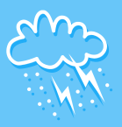 |  | 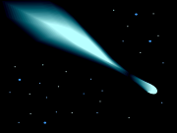 | 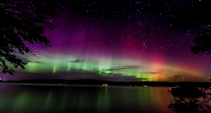  www.accuweather.com/en/features/trend/photos-northern-lights-display/18642257 | 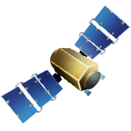
all weather occurs in this  layer; contains most amount of water vapor | ozone layer is here | coldest layers of the atmosphere | hottest layer of the atmosphere | most satellites orbit in this layer
planes fly at the very top of this layer | weather balloons are here | meteors burn up in this layer | the northern lights (auroas) happen here | lowest amount of air pressure
layer closest to the Earth’s ground; highest amount of air pressure | air temperature increase in this layer | atmosphere is very thin | the space shuttle and international space station orbit in this layer | the real beginning of outer space
all living organisms are found here | Cloud free layer of the atmosphere | middle layer of the atmosphere | very thin layer of air | lowest amount of air pressure

