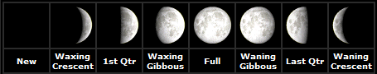
Identifying Phases of the Moon III
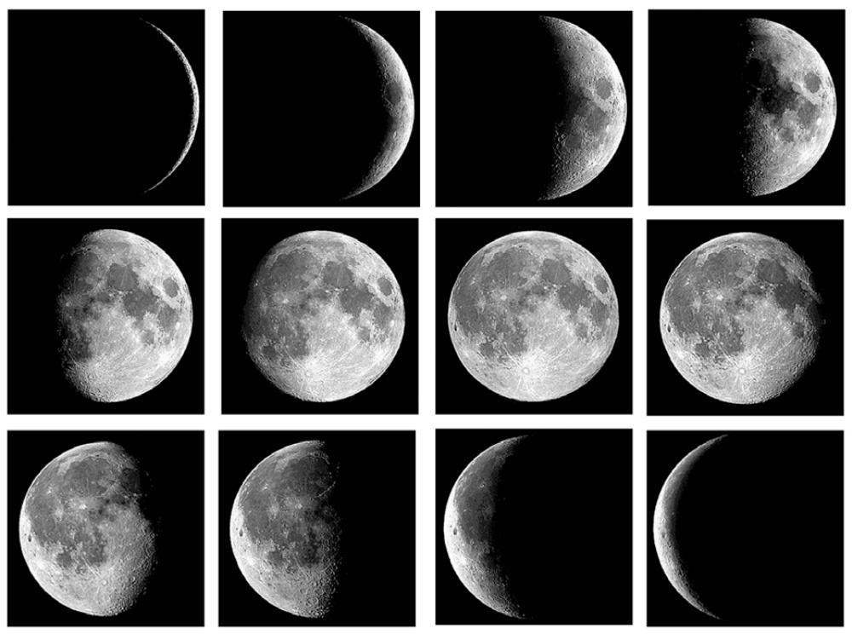
5 6 7 8
9 10 11 12
1 2 3 4

Using the pictures above, complete the worksheet.

Which image shows First Quarter? ______ Full? ______ Third Quarter? ______

Which images are crescents? _________________ Gibbous? _________________

Which images are waxing? ______ through ______

Which images are waning? ______ through ______

