Crystal Felima Social Studies
December 3, 2010 Work hard. Be nice!

Unit Assessment

Standards: Standard 1: Physical and Spatial: Students shall develop an understanding of the physical and spatial characteristics and applications of geography.

Objective: Geographers will be able to demonstrate mastery on “Our Earth” Quiz.

Duration: 40 minutes

Materials:
- Worksheets

Agenda:
- Assessment Expectations
- Assessment
- Closure

Materials: Assessment

Assessment Expectations: Instructor will remind students to maintain their academic integrity by covering their answers; use their best test taking strategies by marking answers that they think are not correct or do not make sense; and if there is any talking during testing, the instructor will be happy to take up their assessment and they will retake the test.

Assessment: Students will be given their assessment. Once students have finished, students will be able to assign themselves by reading a book.

Closure: Instructor will tell students that they will receive their scores next week and that they will be included in their progress reports.

Name: _____________________ Social Studies
Date: ______________________ Work hard. Be nice!
Our Earth Assessment
List the four oceans from largest to smallest:

________________________________________

________________________________________

________________________________________

________________________________________

List the seven continents from largest to smallest:

________________________________

________________________________

________________________________

________________________________

________________________________

________________________________

________________________________

(Numbers 8-18) Please label the four oceans and seven continents below.

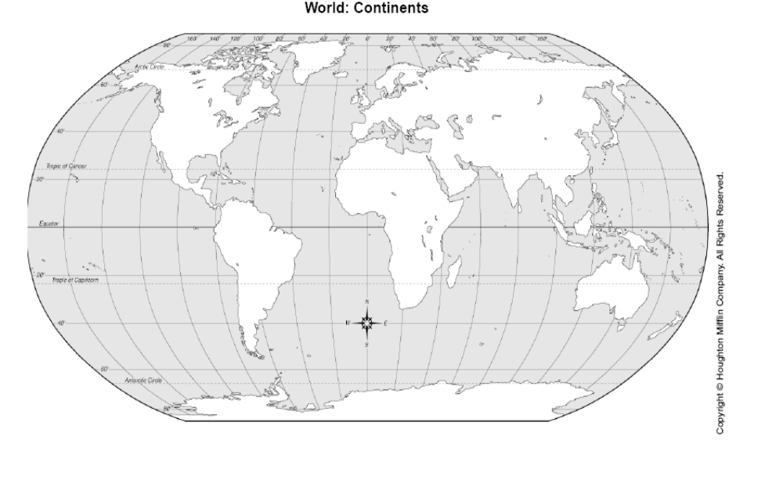

Fill in the blank with the correct LETTER.
- Continent
- Ocean
- Compass Rose
- Hemisphere
- Longitude lines
- Latitude lines
- Equator
- Prime Meridian
  - ___________________ is half of the Earth

  - ___________________ is a huge piece of land on Earth

  - ___________________ is a symbol on a map that shows direction

  - ___________________ is a huge body of water on Earth

  - ____________________are the lines that is halfway between the North and South Pole

  - ___________________are the lines that run east and west around the earth

  - ___________________are the lines that is the starting point for measuring longitude lines

  - ___________________ are the lines that run north and south around the earth

Short Answer:
  - Latitude: Lines of latitude run from _________ to __________

  - Equator: The equator is the line of _________________ at 0°.

  - Prime Meridian: The prime meridian is the line of _________________ at 0°.

  - Lines of longitude run from _________ to _________

  - Please draw and label a compass rose in the space below.

Open Response Questions:
  - Who uses longitude and latitude and what are they used for? __________________________
______________________________________________________________________________
______________________________________________________________________________
______________________________________________________________________________
______________________________________________________________________________
______________________________________________________________________________
______________________________________________________________________________
33). What does “geo” mean? What does “graph” mean? What can we learn from geography?
______________________________________________________________________________
______________________________________________________________________________
______________________________________________________________________________
______________________________________________________________________________
______________________________________________________________________________
______________________________________________________________________________
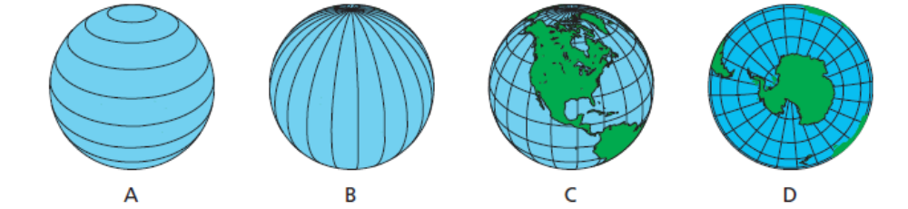
Fill in the blank.
- Latitude and longitude are measured in: ____________________.
- Which picture shows lines of longitude? ______________
- Which picture shows lines of latitude? _________________

Label the hemispheres. (# 37)
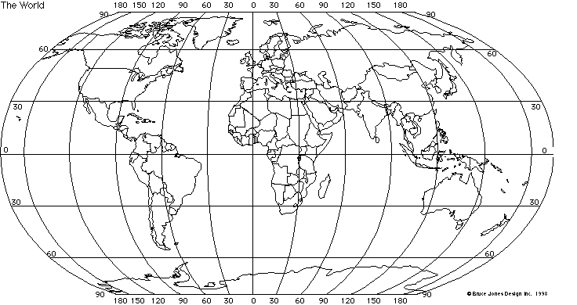
D
E
B
A
C

Using Longitude and Latitude
- Point A is located at _____________________________________.
- Point B is located at ________________________________________.
- Point C is located at ________________________________________.
- Point D is located at ________________________________________.
- Point E is located at _________________________________________.
- The smiley face is located at ____________________________.
Please answer the questions below—Write in complete sentences:
  - If you want to swim from the Pacific Ocean to the Atlantic Ocean, which direction should I go?
_________________________________________________________________________________
  - If you want to go ice skating on the Arctic Ocean, which direction should I go if I’m fishing in the Pacific Ocean?
_________________________________________________________________________________
  - If you are taking a bath in the Atlantic Ocean and I and to go to the Arctic Ocean, which direction should I go?
_________________________________________________________________________________
  - If you are traveling from Europe to Africa, which direction should I go? _______________________
_________________________________________________________________________________

