USA Latitude and Longitude
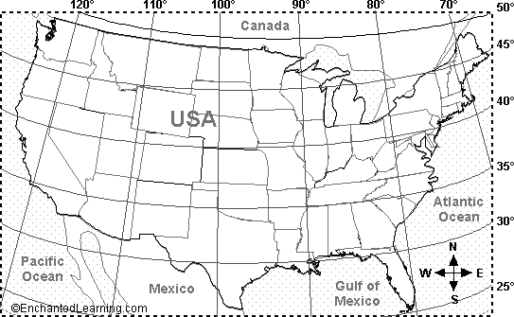

1. The location 26 degrees N, 105 degrees W is in what country? Mark the spot on the map with a black X. | _____________________
2. Is the location 35 degrees N latitude, 75 degrees W longitude in the Atlantic or Pacific Ocean? Mark it on the map with a green X. | _____________________
3. Is the location 30 degrees N, 87 degrees W on land or under water. Mark it on the map with a blue X. | _____________________
4. On the map, label the location 38 degrees N latitude, 105 degrees W longitude with a red X and write the name of the state it is in. | _____________________
5. The location 43 degrees N, 75 degrees W is in what state? On the map, write the state's name. | _____________________
6. Name the state whose southern border is latitude 35 degrees N, and label the state on the map.
