PALEOLITHIC MOBILIARY ART
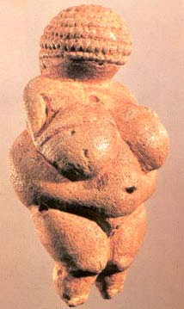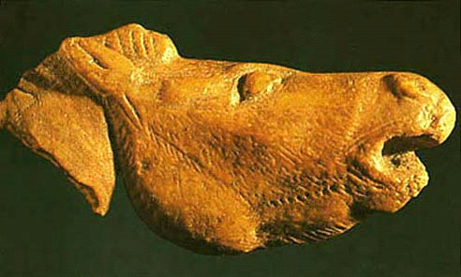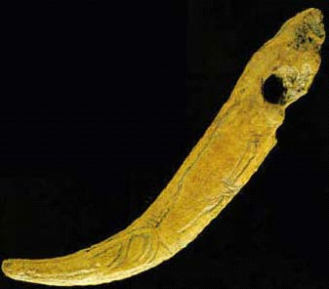
Paleolithic venus figurine whinnying Horse Sculpture In reindeer antler. Truncheon (=power stick) in reindeer antler

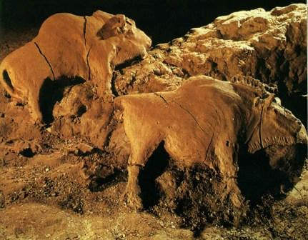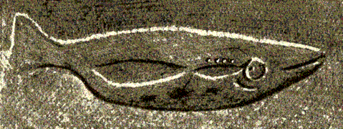
Bisons modelled in clay Engraved fish

