How to Paint an Ancient Egyptian Portrait

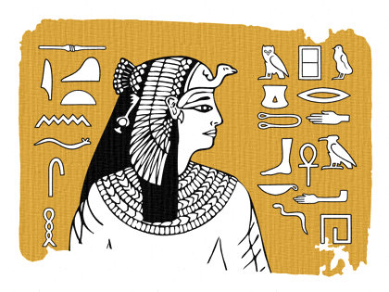
STEP 4. PAINTING THE BACKGROUND
You are now ready to start the painting of our portrait. You should use tempera blocks (the cheap paint discs you get in schools) as these produce the best results.
We have used yellow ochre for the background as this sandy color is often associated with Ancient Egyptian images.
The paint was mixed quite thickly with a little water to about the consistency of double-cream and applied neatly around the head and hieroglyphs.
The borders are deliberately painted more loosely to simulate the edge of an aging piece of papyrus or a decaying mural.

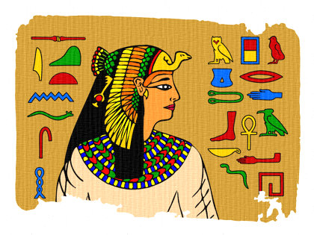
STEP 5. PAINTING THE FIGURE AND HIEROGLYPHS
To complete the painting, carefully fill in the details of the figure and hieroglyphs using a range of appropriate colors.
Strong primary colors (red, yellow and blue) and secondary colors (green, orange and purple), in combination with black and white, were often used in Ancient Egyptian painting.
Note how the rough edge of painting has been continued through the color of the tunic.
Please note that any areas that you wish to remain white, such as the whites of the eyes, must be painted with white paint. It is very easy to miss these when you are working on white paper.
Do not worry if you sometimes paint over a section of black line. It will not ruin the overall effect.
Note: Let all the paint dry thoroughly before you start the next stage.

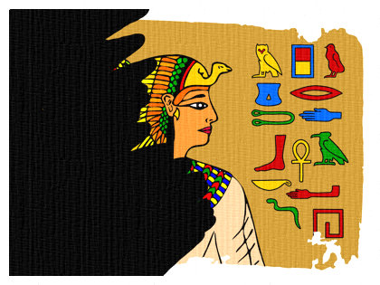
STEP 6. INKING OVER THE IMAGE
This is the scary part. Using black Indian ink, paint over the entire picture. The aim is to lay a skin of Indian ink on top of the painted image.
Next, leave it for several hours until it is completely dry.
Do not worry when your image disappears under the black ink. It will reappear during the next stage.
Note: Try to cover you picture in a single coat. Use soft, even brushstrokes to liberally apply the ink. Continued brushing over one area will start to dissolve the paint underneath and, once dry, you will find it impossible to remove the ink from that area.

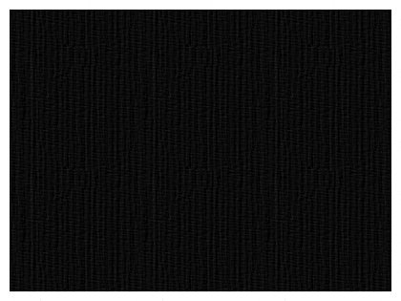
STEP 7. THE INKED IMAGE
Once your picture is completely covered with Indian ink, leave it aside to dry, at least for several hours but preferably until the next day.
When you are sure that your paper is bone dry, hold the picture at opposite corners and carefully run it under a hot water tap.
The Indian ink will begin to flake off and some of the thicker paint will wash away.
The colors will pale slightly and some patches of ink will remain stuck to the painting.
Lay the finished picture on a flat surface and absorb any excess water with paper towels. Then leave it to dry.
The final effect will reveal the ageing texture of an Ancient Egyptian parchment or wall painting.

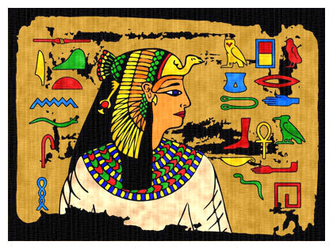
THE FINISHED PORTRAIT OF QUEEN NEFERTARI
This is the kind of image that should appear at the end of the Paper Batik process.
All the areas where the charcoal drawing was exposed or any unpainted patches should have absorbed the ink.
The painted areas should look more translucent and weathered.
Sometimes all the Indian ink does not wash off but this is not a problem. Patches may remain where the paint has been too thinly applied. However, these patches often add to the perished and ageing effect of the image.

