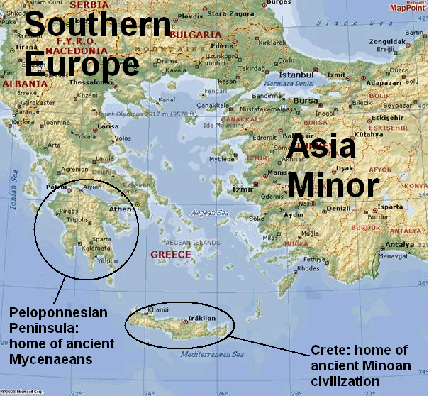
Why Greece is important?
It is hard to imagine a world without Greece because virtually every aspect of modern life owes something to the ancient Greek. This particularly so in Western nations such as the United States and France, where people enjoy the freedoms associated with democracy, a form of government created in Athens some 2,500 years ago. There are all the benefits of science, not to mention the arts, from architecture to theater, which would be completely different without the Greek Legacy. Even sports owe a huge debt to Greece, where wrestling, track & field, and a number of other athletic events were born. Finally, there is language itself, which is filled with words derived from Greek—athletic, architecture, democracy, theater—and history.
The Minoans (c. 2000-c. 1420 B.C.)
At some point during the Neolithic Age, a people called the Minoans settled on Crete. Historians do not know where the Minoans came from. In about 2000 B.C., the Minoan civilization underwent a sudden upsurge, entering a golden age. For the next five centuries, it would rival the great civilizations of the time. The Minoans had their own form of writing, which archaeologists refer to as Linear A. However, Linear A has never been deciphered; therefore most of what is known about ancient Crete is the result of archaeological finds.
During the zenith of Minoan, civilization, Minoan kings appear to have been fair rulers who worked to build up their land as an economic power rather than a military power. The Minoans founded colonies on the mainland of Greece, Asia Minor, and on the islands between. Yet they did no put much effort into building up their military. Again, they were more concerned with trade than with warfare.
The Minoans, in fact, were the first great seafaring empire. They built the best ships of the time, and traded with Egypt, Sumer, and other ancient civilizations. Because of their naval superiority, they often became “middle-men” for other countries, transporting goods from one place to another and often going into relatively remote parts of the world. They were also accomplished craftsmen, producing jewelry, pottery, and dyed textiles that spread to the rest of the Mediterranean on Minoan ships.
It appears that the major centers of Minoan civilization disappeared about 1450 B.C. Archaeologists are unsure as to why Minoan civilization ended so abruptly; however, many speculate either an earthquake or a tidal wave was the cause of the sudden loss.
The Mycenaean Age (c. 1650-c. 1100 B.C.)
The Mycenaeans probably came from the Black Sea area starting in about 2800 B.C. Their language was an early form of Greek. By 2000 B.C., they had conquered the native peoples of Greece and had settled on the Peloponnesian Peninsula. A warlike people, the Mycenaeans built a civilization that flourished throughout the region.
The Mycenaeans, who had lived in the shadow of the Minoans for a long time, adopted aspects of Minoan civilization. Their language was probably unrelated to the Minoans; however, in its written form, they adapted it to the Minoan script, which has been dubbed “Linear B.” (Unlike Linear A, Linear B has been deciphered.) Like the Minoans, the Mycenaeans also became great traders. Their trade only increased after they conquered Crete.
Despite their ties to Crete and the Minoans, the Mycenaeans’ civilization developed in a very different direction. Mycenaean society was dominated by intense competition, frequent warfare, and powerful kings. To raise money to build great palaces and high walls, Mycenaean kings taxed trade and farming. To show off their strength, they built great monuments.
War played a part in the end of Mycenaean society. Along with droughts and famines, invasion from outside, and the end of trade, war between Mycenaean cities sped up their downfall. A dark age followed. People fled cities, struggled to farm enough to eat, fought their neighbors and outside invaders, and even lost the use of writing for several centuries. Greek civilization almost disappeared.
Review: (Answer in complete sentences on a separate sheet of paper. Keep the reading for your notes when you have completed the assignment.)

Remembering—
1. What two civilizations were important to early Greek history? Which came first?
2. From which civilization is the modern language of Greek derived?
Understanding—
3. What statements support the notion that the Minoans cared more about trade than fighting? (x3)
4. How were the Mycenaeans different to the Minoans? Explain.
Analyzing—
5. Explain the relationship between the Minoans and the Mycenaeans. Were they more like two siblings or like a father and son? Explain.
Evaluating—
6. From the little you know of the Minoans and the Mycenaeans, which society was more successful? How do you know? (3-4 sentences minimum.)

