The Minoans and the Mycenaeans were two of the early civilizations that developed in Greece.
Minoans
The Minoans built a large civilization on the island of Crete that flourished from around 2600 BC to 1400 BC. They built a powerful civilization based on a strong navy and trade throughout the Mediterranean Sea. The Minoans had their own written language which archeologists call "Linear A."
City of Knossos
At the center of the Minoan civilization was the city of Knossos in Crete. Knossos had a huge palace and a population of over 10,000 people at its peak. Many beautiful pieces of art and pottery have been found within the palace. According to Greek Mythology, the city was once ruled by King Minos. In the myth, King Minos built a large labyrinth under the palace where a monster called the Minotaur lived. Minoans were ruled by kings. They were a pacifist civilization as their palaces and cities did not have walls.
The Minoan civilization began to weaken around 1450 BC. Archeologists think this might have been due to a natural disaster such as an earthquake
Mycenaean civilization
The Mycenaeans developed on mainland Greece and ruled the region from around 1600 BC to 1100 BC. The Mycenaeans lived mostly on mainland Greece and were the first people to speak the Greek language. Their largest city was called Mycenae, which gives the culture its name. Mycenae was a large city surrounded by walls. There were other Mycenaean cities that grew into major city-states during the height of Ancient Greece such as Thebes and Athens.
The Mycenaeans developed trade throughout the Mediterranean. They built large trade ships and traveled to places like Egypt where they traded goods like olive oil and wine for metals and ivory.
The Mycenaeans took over the islands of the Minoans and adopted much of the Minoan culture. They adapted the writing of the Minoans to their own language. Today this writing is called "Linear B."
The Mycenaean civilization began to collapse around 1250 BC when many of their cities were burnt to the ground. After this, they continued to decline and were not a major power in the region. Archeologists are unsure of what caused the collapse. It might have been foreign invaders such as the Sea Peoples or the Dorians. It may also have been a natural disaster such as an earthquake or drought.

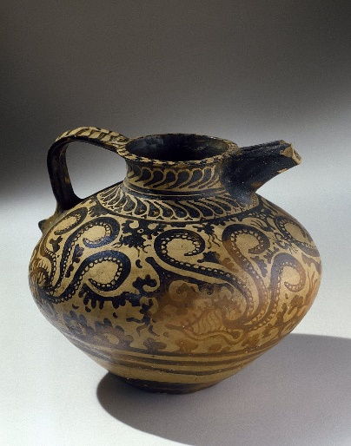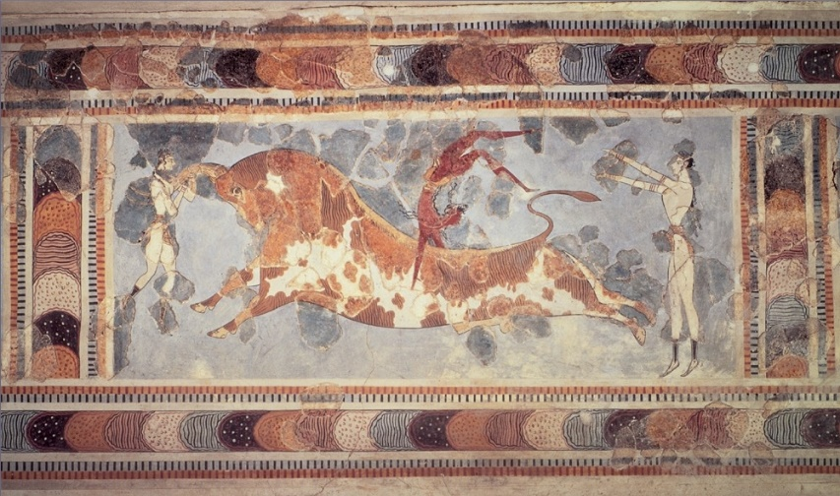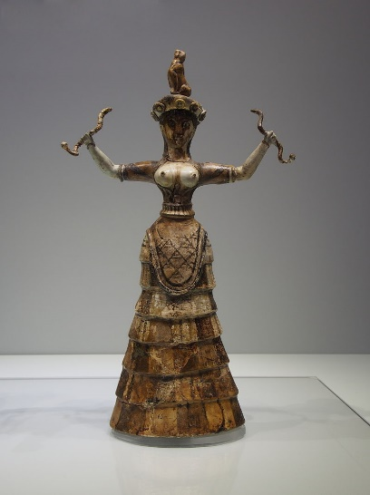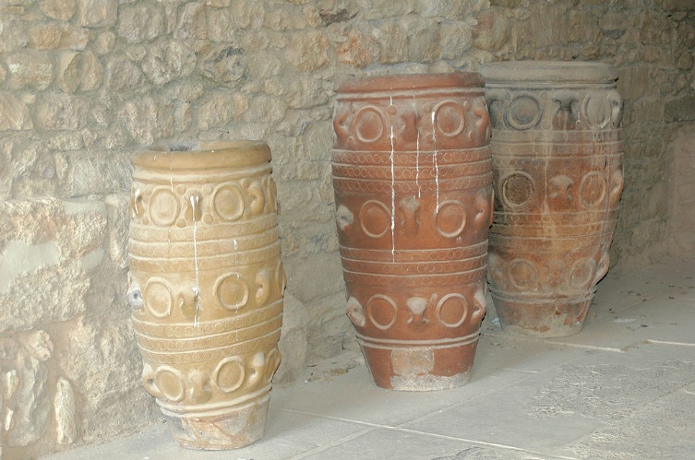

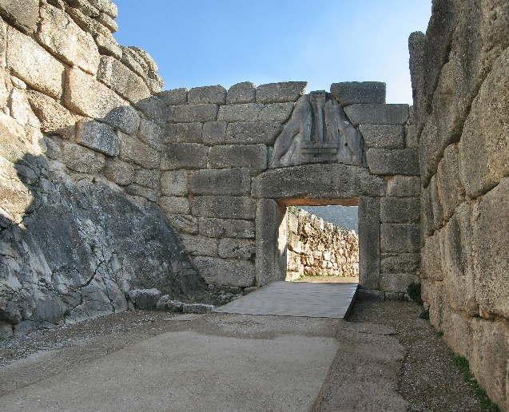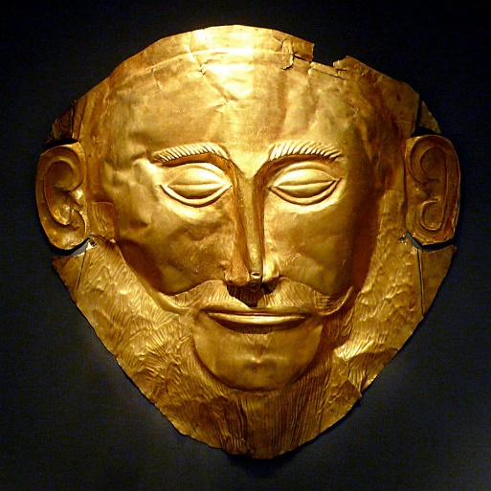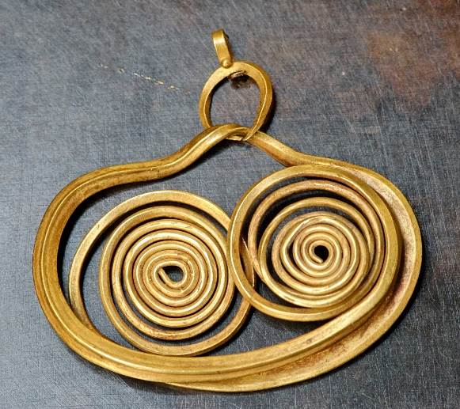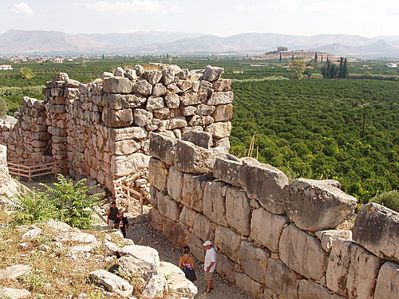

 | MINOANS | MYCENAEANS
CHRONOLOGY

GEOGRAPHICAL LOCATION

GOVERNMENT

CITIES AND THEIR CHARACTERISTICS

ECONOMY

CULTURE
END OF THE CIVILIZATION

