Alexander the Great Skeleton Notes
  - Ruler of the World
  - (no, really…like…the whole thing!)

Why the “Great”?
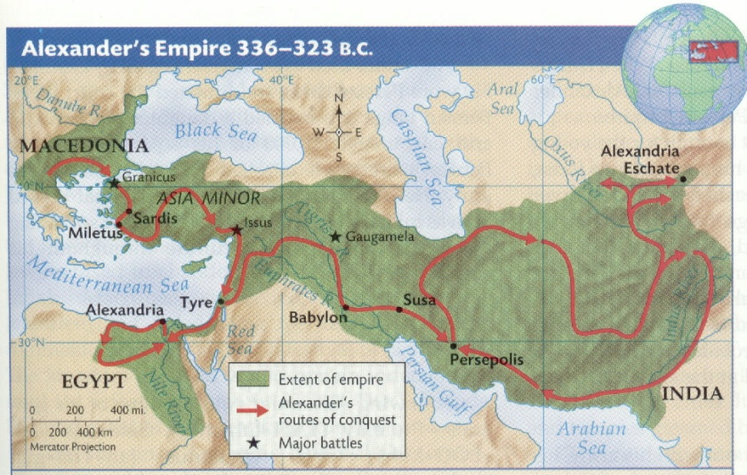
- In ten years, Alexander of Macedonia created the _______ empire in the world up to that time
- Alexander spread Greek culture, ensuring _________ diffusion and the __________ of the qualities of classical Greece

Alexander’s Origins
- Born in ________, Macedonia
- Tutored by the Greek philosopher, _____________
- His father, Philip, was __________ of Macedonia, and had conquered the Greek city states during his ______ year reign

Alexander Rules
- Philip was _________ in 336 B.C. by an assassin…maybe hired by his _______, Olympia…
- So Alexander was only _______ when he became ________ of Macedonia

Securing His Father’s Empire
- Alexander squelched ___________ in the northern regions to the Danube River
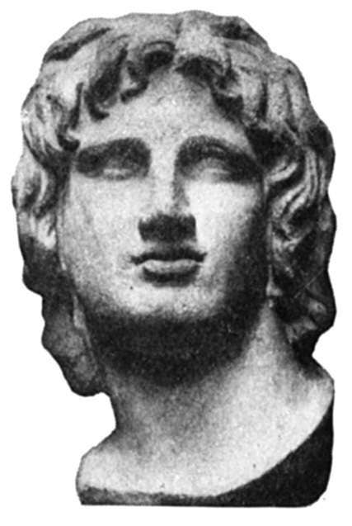
- In the process of ____________ the Greek city states, his forces destroyed Thebes, massacring all, including __________ and children
Who needs fingers when you got a sword?!

Expanding the Empire
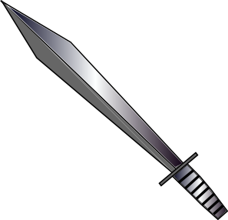
- Alexander’s forces of over __________ crossed at the Dardanelles into Asia,
where he declared that the whole of Asia would be won by the __________

The Gordian Knot

- The Gordian Knot: the legend behind the ancient _______ was that the man who could ______ it was destined to rule the entire _____
- Alexander simply slashed the knot with his ______ and unraveled it.

Defeating Darius of Persia
- Alexander’s forced dispatched the Persian _______, losing only 110 men (legend)
Wait... Alexandria was north of the delta that split Upper from Lower Egypt, so it was in ___________ Egypt

- Again Alexander was victorious, and Darius was forced to ______, abandoning is ________, wife and children to Alexander
- Major cities in _______ ________ and along the Phoenician coast surrendered to Alexander
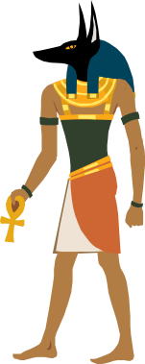
- Alexander proceeded to _________, where he established the city of Alexandria and was made ___________
- Yet again, Alexander’s forces defeated Darius, this time in _____________…
- Alexander was proclaimed king of _________ and Darius’s royal city and palace were __________ to the ground…
Not cool bro
- Again, Darius fled… Alexander pursued…
- When Darius was found murdered by his own men, Alexander executed the assassins and gave Darius a royal ___________

The Limits of Expansion
- In the spring of 327 BC, Alexander and his army marched into _________
- As he conquered regions he allowed _________ to continue to govern in his name

Retreat
- At the Indus, the Macedonians rebelled and ___________ to go any farther
- The forces travelled down the Indus and began the arduous _______ back to Mesopotamia
- His best friend, Hephaestion, died of a fever; to console himself, Alexander led a ferocious military campaign and went on a drinking binge

Securing a Legacy
- Alexander made Babylonia the _________ of his Empire
- He married one of Darius’ ____________ and “encouraged” 10,000 of his soldiers to take Persian wives
- He died the following year at ____ before he could produce an heir and his kingdom was divided among 3 of his __________

The Mystery of Alexander’s Death
- Alexander died of a fever at 33… but why?
- Plutarch reports that he was had been _________ by several bad “omens”
- Some others from the time claimed Alexander was ____________ during the drinking binge

