Rome Unit Pt. 1: The Republic
2013
Waters & Anderson
ZBTHS
8/1/2013
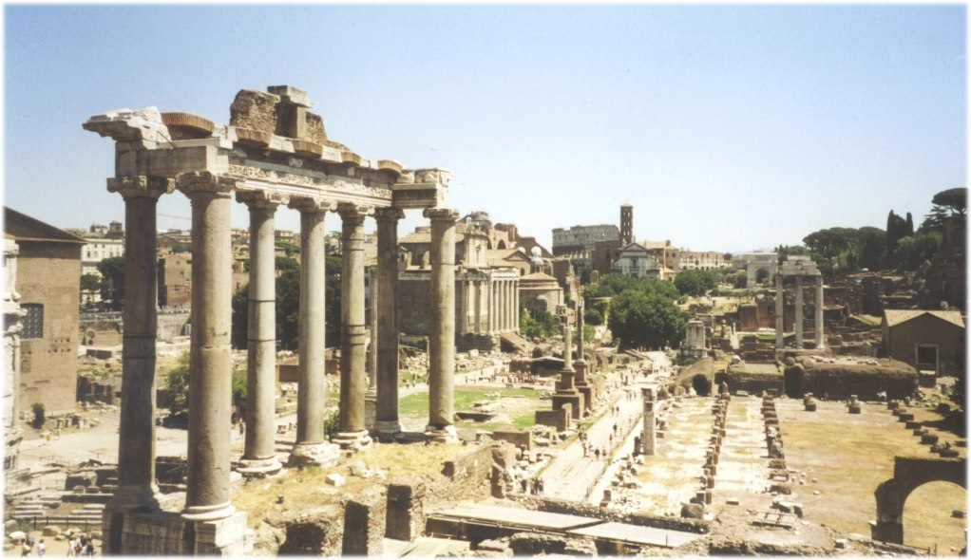
Rome, Part I: The Republic
Contents
ACT-Style Readings
- Early Rome: A Blend of Cultures
- The Roman Republic
- Roman Dining
- Roman Architecture
- Hannibal Barca
- Gladiators
- Where are Antony & Cleopatra?
Main Idea/Supporting Details Exercises
- Roman Bathing
- Roman Slavery
- Julius Caesar
- Augustus Caesar: An Empire is Born
Primary Source/Artifact Analysis
- Ancient Rome: Analyzing Primary Sources
Writing Assignments
- Narrative: Do you think Hannibal right to attack Rome? Why or why not?
- Narrative: There is a famous phrase, “When in Rome, do as the Romans do.” If you lived in Ancient Rome, how would you act?
- MEL-Con: How does the geography of Ancient Rome give the Romans an advantage or disadvantage over other civilizations we have discussed so far?
Projects
- No Place Like Rome advertisement
Other
- K-W-L Chart for Roman History
- Romulus & Remus: Founders of Rome reading
- Ancient Rome: Italian Peninsula map worksheet
- Roman Vocabulary
- Roman City guided video questions
Lesson: 1 | Topic: Intro to Rome
Standards: | Learning Outcomes:  - Students will activate knowledge and interest in Ancient Rome.
Activities:
Opener: Ask students what things a city/state needs to operate and keep people happy (running water, entertainment, laws). Create a list on the board and discuss how each item contributes to a healthy society.

Activity 1: Students will complete the K of a KWL chart about Ancient Rome with known facts about Roman life, culture, and achievements.

Activity 2: Reading: “Romulus and Remus: The Founders of Rome” and questions.

Activity 3: Map activity worksheet, to be completed with textbook/mobile devices.
Materials Needed:  - KWL Chart  - “Romulus and Remus”  - Map activity  - Textbook or mobile device with Internet | Assessments:  - List of society characteristics on the board  - KWL Chart  - Reading responses

Name: _______________________________________ Date: _______________ Period:______

K  What do you know? | W  What do you want to find out? | L  What did you learn?

Name: ______________________________ Date: ________ Period: ____
Romulus and Remus: The Founders of Rome
A
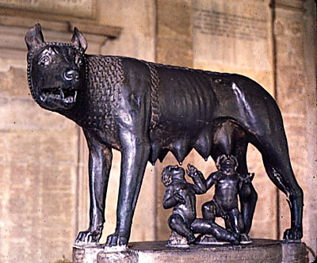
ccording to legend, Remus and Romulus were born as grandchildren to King Numito on the Italian Peninsula. Numito's brother, Amulius, started a war to overthrow his brother, after which Numito was imprisoned and his daughter, Rea Sylvia, was forced to become a Vestal Virgin (female priests), so that she would not bear any children.
But Sylvia became pregnant and gave birth to twins, boys, who were called Romulus and Remus. It is said that Mars, the God of War, was their father. Amulius wanted the children dead and ordered them to be thrown in the Tiber River. But the children were put into a basket and floated to safety. The babies were found by a she-wolf, which took care of the children and breast-fed them.
A shepherd came across the basket and adopted the boys. The boys grew as shepherds and became natural leaders. When they became adults, they realized they who they truly were and rebelled against Amulius. They reinstated the true king, Numito, and set out to look for a place to build their own city. In 753 BCE they stopped at the Tiber River, where they had been found by the shepherd, and where there were seven hills.
They decided to build a city on one of the hills. But they could not decide who should rule in it, so they asked the gods for a sign. They each awaited an answer from the gods on a different hill. Remus saw the first sign – six vultures flew above him. Shortly after that, Romulus saw twelve vultures flying over his head and claimed kingship for himself. Remus started to mock at his brother and the two began to fight. Remus was killed and Romulus went on to build his own city and name it after himself: Rome.
- Is this a true story or a myth? How do you know?

- Rome was born from conflict. Do you think Rome will grow up to have a peaceful or a violent culture? Explain your answer.

- Based on the reading, do you think Rome was an empire that valued religion? Why or why not?

Name: ______________________________ Date: ________ Period: ____
Ancient Rome: The Italian Peninsula

Directions: Use your book or Internet-enabled device to label the following geographic places:

Tiber Riber Rome (city) Sicily Alps
Adriatic Sea Ionian Sea Corsica Mediterranean Sea
Sardinia Danube River Gaul Tyrrhenian Sea
Carthage (city)
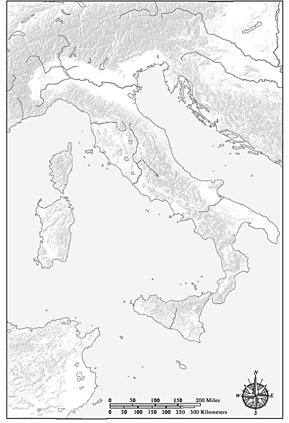
Lesson: 2 | Topic: Roman Republic
Standards: | Learning Outcomes:  - Compare the geography of ancient Rome to Ancient Greece  - Students will be able to answer questions about formation and daily life of the Roman Republic
Activities
Activity 1: Review Italian Peninsula map for opener.

Activity 2:
- Pair reading: “Early Rome: A Blend of Cultures”
- Students answer questions and fill in Venn Diagram
- Review selected questions as a class to complete student understanding of Roman geography

Activity 3:
- Mel-Con: How does the geography of Ancient Rome give the Romans an advantage or disadvantage over other civilizations we have discussed so far?

Activity 4: Begin reading “The Roman Republic” and finish for homework.

Materials Needed:  - “Early Rome: A Blend of Cultures”  - “The Roman Republic”  - MEL-Con web | Assessments:  - Reading questions  - Collect map activity  - MEL-Con

Name: ______________________________ Date: ________ Period: ____
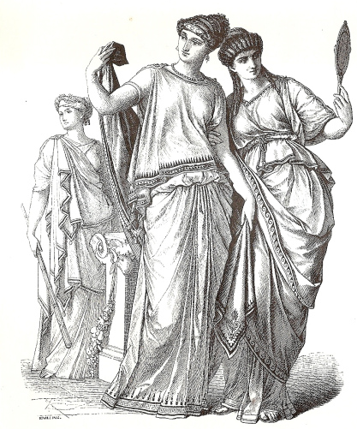
Early Rome: A Blend of Cultures
I
taly is a peninsula in the Mediterranean Sea to the west of Greece. Greece and Rome share similar climates of warm, dry summers and mild winters. Unlike Greece, Italy does not have very good mineral resources or harbors. Italy, however, is less mountainous than Greece, is easier to travel through, and has much fertile land. It is no surprise that Rome was founded as an agricultural society while Greece had to rely on trade and the seas to survive.

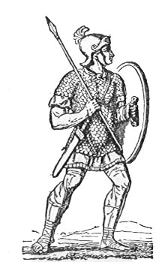
The Italian Peninsula is more closely linked to the rest of Europe than Greece is. While a mountain range known as the Alps to the north is a natural barrier, many tribes crossed into Italy or sailed and established colonies on its shores (including the Greeks!). The early Romans developed a strong military to defend against raids and a navy to defend ships using the Mediterranean for travel.

It is believed that, after Rome was founded by Romulus, the Romans began to expand and conquer neighboring tribes called the Latins and Etruscans. While Greeks sought to spread their own culture, early Romans were very adaptable and borrowed ideas from everyone they met. They learned metalworking and architecture (especially using arches) from the Etruscans, learned how to grow grapes and olives from the Greek colonies, borrowed the alphabet and language from the Latins, and even developed a religion based on Latin and Greek deities.

Rome gradually expanded but was still controlled by Etruscan kings. Romans wanting their own identify and unhappy with paying tribute to a harsh ruler overthrew the Etruscan king in 509 BCE and founded a new government called a republic. They swore to never again be ruled by a king and instead let the people elect leaders to lead and serve the best interests of Rome. This was the beginning of what is known as the Roman Republic.
Dictionary
Peninsula (noun): a body of land jutting into and nearly surrounded by water.
Deities (noun): gods/goddesses
Republic (noun): a form of government in which power is held by citizens who vote on their leaders
- What is the main idea of this passage?
The Greeks and Romans share a common history.
The Romans developed their identity by learning from those around them.
Italy is a harder place to live than Greece.
Romans learned to overthrow their kings from the ideas of the Greeks.

- Why did Romans develop a military/navy?
To conquer the Greeks and Gauls to the north
To teach young men the skills they need to survive
To lead pilgrims to the Holy Lands east of Greece
To defend against raiding tribes in Italy
- Complete the Venn Diagram below with at least 3 facts in each space based on your prior knowledge and the passage:
Greek Geography Roman Geography


- How did the geography of the Italian Peninsula allow a large civilization such as Rome to develop and grow?
- According to the passage, what was the main difference in how the Greeks and Romans conquered other peoples?

Name _____________________________ |  |  | Date ___________________

The Roman Republic
adapted from Vickie Chao

¹ For centuries, Italy's Rome has been an important city, playing a pivotal role both culturally and politically. According to the legend, a pair of twin brothers built Rome from scratch in 753 B.C. In a quarrel, Romulus killed Remus. After that, he named the city after himself and became the first ruler of Rome. While this story is fascinating, its authenticity is very much in doubt.
² Historians have long established the fact that Rome had existed since 900 B.C. By about 600 B.C., a group of people called the Etruscans (pronounced "ih-TRUS-kunz") took power in Rome. They ruled it for nearly a century. Though the Etruscans left behind many imprints, we know very little about them. In fact, we cannot even say for sure where they came from. Some scholars believed that the Etruscans were native people of Italy. Others believed that they were immigrants from Asia Minor (today's Turkey). Regardless of their origin, we know for certain that the Etruscans spoke a language different from that in Rome. We also know for certain that their authoritarian style of governing was very unpopular. In around 510 B.C. or 509 B.C., the Romans revolted. They expelled the last Etruscan king, Tarquinius Superbus (pronounced "tahr-KWIN-ee-us soo-PUR-bus", also known as Tarquin the Proud).
³ With the Etruscans gone, the Romans decided that they would never want to go back to the days of monarchy. To avoid giving too much power to a single person, they came up with the idea of the republic.
⁴ In this new form of government, all citizens who had the right to vote could participate in the selection of their leaders. Once a year, they elected two consuls. The individuals who won the office acted on the advice given by the senate. They were responsible for enforcing the laws and policies of the Roman Republic. Because the consuls would later become senators after their one-year term in office, they almost always did what the senate wanted them to do. As the two men met and discussed state affairs, they attempted to reach unanimous decisions. In the event of a disagreement over serious matters, Roman law allowed the senate to appoint a dictator. This person would act as a king, but his power was only good for six months.
⁵ In the early days of the Roman Republic, all the senators were the nobles, or the patricians. This arrangement did not sit well with the commoners, or the plebeians. As the distrust worsened, the plebeians went on strikes. In 494 B.C., they set up their own assembly. They declared that the assembly's tribunes (elected once a year) had the power to reject any decision made by Roman officials or even the senate. In 450 B.C., the patricians agreed to one of the plebeians' main demands and established the Law of the Twelve Tables. These laws hung openly in marketplaces for everyone to see. It was applied equally to all citizens. Encouraged by the victory, the plebeians continued to fight for their rights. In 367 B.C., they overturned a law that barred them from being consuls. In 287 B.C., they expanded the assembly's legislative power from making laws for the plebeians only to making laws for all Roman citizens!
⁶ As the government structure continued to take shape, the Roman armies went on to conquer new territories for the Republic. The added land did not bring joy. Instead, it brought forth a big problem. Some suggested the land be given to the plebeians. Others refused. The dispute paralyzed the entire nation. Soon, civil wars erupted. Just when the Roman Republic was heading toward total destruction, a general named Julius Caesar rose to power.
⁷ Julius Caesar was a military genius who fought and won numerous wars. In 49 B.C., he led his troops back to Rome and fought against the senate’s policies. He won. The senate made him a dictator the following year. Under Roman law, a dictator could rule for only six months. But the senate made an exception, allowing him to be dictator for life. As Caesar's power continued to grow, some senators began to feel uneasy. They felt Caesar had gone too far and had become too powerful. They decided to get rid of him. On March 15, 44 B.C., they assassinated him.
⁸ The death of Caesar pushed Rome into turmoil again. The chaos lasted for more than ten years. In the end, Caesar's adopted son, Octavian, managed to quash all the opposing forces and won the civil war. The senate awarded him the title of Augustus (meaning "highly respected") in 27 B.C. It also gave him the absolute power to rule Rome, effectively making him a king. From that point forward, ancient Rome was once again under the control of monarchy. Though Augustus never coined the term "Roman Empire," historians all agree that he was the first emperor of this newly united kingdom. Thus, 27 B.C. became both the end of the Roman Republic and the beginning of the Roman Empire

- How long was Rome considered a Republic?
  - 483 years
  - 467 years
  - 510 years
  - 287 years

- According to the reading is the end of the Roman Republic?
  - The death of Julius Caesar
  - The Romans expelling the Etruscan King
  - Augustus had complete control of Rome
  - Augustus assassinated Julius Casesar

- Why did the plebeians establish their own assembly in 494 B.C.?
  - Because they wanted to have freedom of speech
  - Because they wanted to get more land
  - Because they wanted to have equal rights as the patricians
  - Because they were bored

- Why would the Roman senate want a dictator?
  - To take out opponents of Rome
  - To guarantee a victory in battle
  - To settle a dispute between the two consuls that dragged on too long
  - Romans never wanted a dictator in charge of their government

- What is the main idea of the 7th paragraph?
  - Caesar was a genius
  - Caesar and his army won several battle
  - Caesar’s was assassinated by the senate
  - Caesar’s power continued to increase until his murder

Lesson: 3 | Topic: Roman Culture
Standards: | Learning Outcomes:  - Develop understanding of Roman customs and culture  - Students will compare Roman culture to contemporary lives.
Activities
Activity 1: Opener will compare the origin and government of the Roman Republic to the origins and government of the United States.

Activity 2:
- Class reading of MI: “Roman Bathing”
- Students answer questions and compare as a class to check for understanding

Activity 3:
- Class compiles a list on the board of their ideal “feast,” including number and description of courses and how many people they would invite.
- Pairs read “Roman Dining” and answer questions

Activity 4: Begin reading “The Roman Republic” and finish for homework.

Materials Needed:  - MI: “Roman Bathing”  - “Roman Dining” | Assessments:  - Reading questions

NAME: _________________________ PER: ______ DATE: __________
Main Idea/Supporting Details: “Roman Bathing”
YOUR GOAL: Accurately IDENTIFY the MAIN IDEA of the entire reading, PROVE that your answer is correct, and ASSESS YOURSELF to see how you’ve grown as a thinker.
After you read the passage, you will create a one-statement summary of the “Main Idea.” Your statement should accomplish each of the following:
- It is a statement of YOUR creation (not copied from the passage itself).
- It represents the ENTIRETY of the passage rather than merely restating portions of the passage.
- It is a complete statement that gives the reader a sense of the author’s intention.
--good—“The policies of Barack Obama and George W. Bush are drastically different in many areas.”
--not so good—“It’s about the policies of Barack Obama and George W. Bush.”
“Roman Bathing”
¹ The Romans were very serious about bathing. To appease the demand of daily baths, all cities and towns had public and privately-owned bathhouses. All bathhouses used the so-called hypocaust system for central heating. They had fire grates in their basements. When fires were lit in the grates, hot air flew through the wall ducts. It warmed up the baths. The floor at ground level was supported by concrete or brick pillars. Both building materials were great for retaining heat.
² Interestingly, the Romans did not wash their bodies with soap. They used oil instead. After undressing, they would usually rub oil onto their skin and head to a "warm room." Once there, they might lunge into a pool of lukewarm water for a while. Or they might simply sit around chatting with their friends. When they felt it was about time to move on, they would then go to a "hot room." A "hot room" was like a sauna. It was hot and steamy. As the Romans sat and perspired, they used a tool to scrape dirt off their skin. The tool had a specific name. It was called "strigil." It was made of wood, bone, or metal.
³ Now, with filth thoroughly scrubbed off, the Romans would first take a quick dip in a hot pool and then in a cold one. After they completed the ritual, some would even hire attendants for massages or haircuts.
⁴ Roman bathhouses, in many ways, are like our spas. But they offered more services. Beyond the usual pools, Roman bathhouses also had gardens, exercise yards, reading rooms, and even libraries. They had concession stands and restaurants. Because of the many features and low admissions, the Romans went to bathhouses very often. Sometimes they went for cleaning their bodies. Sometimes they went for catching up with the latest gossip. Sometimes they went for business meetings. And sometimes they went for curing minor ailments. Regardless of what drove them to go, the Romans took their bathing very seriously. Later as they invaded other countries, one of the first things they did when they arrived was to build a bathhouse. By doing so, they brought with them a piece of memory from home. They knew that no matter where they were, they could always count on going to a bathhouse and having a good time.

PART 1: IDENTIFY THE MAIN IDEA
Remember: Main Ideas represent the ENTIRETY of a passage, not merely sections or specific examples.
DIRECTIONS: Create a main idea statement that represents the entirety of this passage.

PART 2: PROVE YOUR ANSWER
DIRECTIONS: Explain why you wrote this answer. In the box below, write at least 5 statements that support the main idea. If you cannot provide at least 5 statements supporting your main idea, you probably do not have a main idea.

PART 3: POST-DISCUSSION SELF ASSESSMENT
DIRECTIONS: On the line below, mark an “X” where you believe your main idea statement belongs.
PERFECT!______________________________________________COMPLETELY WRONG!

Name _____________________________ |  |  | Date ___________________

Roman Dining

¹ What did the ancient Romans eat? If your answer is pasta or pizza, you are in for a surprise!
² Back in the old days, the Romans ate three times a day, just like us. Both their breakfast and lunch were quite simple. For their first meal, they would usually have bread with honey or watered down wine. (The Romans thought it rude to drink wine straight up.) For their second meal, they would eat bread with cheese, dates, fruits, and occasionally, some meat. The two modest fares were enough to aid them for a day of hard work. At dusk, they headed back home to enjoy their main meal, dinner.
³ The Romans loved to hold dinner parties. Before their guests arrived, they would have their servants arrange three couches around every low dining table. Each couch could hold up to three people. The Romans had an interesting dining habit. They liked to eat while lying down!
⁴ Just as each dressed-up guest took up a spot on the couches, the servants began to bring out food and lay it on the tables. On the menu were three courses - appetizer, main course, and dessert. Each course could consist of several dishes. The Romans ate all sorts of vegetables, fruits, and meats. They liked olives, asparagus, mushrooms, beans, and broccoli. They liked apples, pears, figs, dates, and grapes. They liked fish, oysters, lobster, eggs, poultry, and pork. They rarely ate beef. And they did not know about potatoes or tomatoes. The Romans put a lot of sauce in their food. They especially liked garum. Garum was a condiment made from fish, salt, and herbs. It could be bought ready-made from a marketplace. At dinner parties, the guests were often served exotic food. They might have boiled ostriches. They might have roasted flamingoes. Or they might even have stuffed dormice sprinkled with honey and poppy seed.
⁵ No matter what was on the menu, the guests could always count on having a tasty treat. When the feast finally began, everybody dug in - truly. As there were no table knives or forks back then, people ate mostly with their hands. Sometimes, they ate with spoons, too.
⁶ Dinner parties in ancient Rome could go on for hours. And they cost a lot of money. Besides the food, the hosts would need to prepare many varieties of wine. They would also need to hire clowns, dancers, or musicians to perform in between courses. When the guests finally rose to leave - hopefully all stuffed, drunk, and well entertained, the hosts were left with piles of dirty dishes and high bills.
⁷ Since dinner parties were costly, only a few in ancient Rome could afford them. Most people were poor. They lived on government subsidies. Without even having kitchens in their apartments, many ate take-out or used communal ovens. For the commoners, bread was their staple food. Meats were for special occasions only. For them, boiled ostriches, roasted flamingoes, or stuffed dormice were things far beyond their wildest imagination!

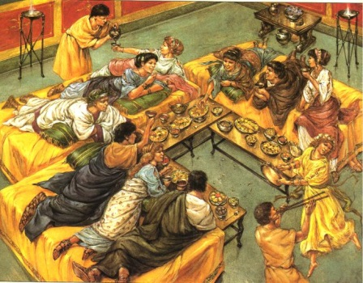
- Which meal was the most important one for the ancient Romans?

- Which of the following did the ancient Romans not eat?
  - Grilled fish
  - Boiled chicken
  - Mashed potatoes
  - Roasted pork

- If a host invited 16 people to a dinner party, how many couches did he need to prepare?
  - 3
  - 9
  - 4
  - 6
- Which of the following about the ancient Romans' dinner parties is true?
  - The guests ate while lying down on couches.
  - Each guest was served one type of appetizer, one main course, and one dessert.
  - The guests needed to bring their own wine.
  - The hosts would ask the guests to share some expenses.
- Compare a Roman dinner to your dinner on the Venn Diagram below:

Lesson: 4 | Topic: Roman Architecture
Standards: | Learning Outcomes:  - Develop understanding of Roman architecture, construction methods, and building functions
Activities
Activity 1: Opener question—List what you think are 5 of the most famous/important buildings in the US. What are their functions? Class will list these on the board and discuss what they are used for, drawing connections to buildings in Ancient Rome.

Activity 2:
- Class reading of “Roman Architecture”
- Students answer questions and compare as a class to check for understanding

Activity 3:
- Class will begin viewing David Macaulay’s Roman City and answering questions during the video.

Activity 4: Begin reading “Roman Slavery” and finish for homework.

Materials Needed:  - “Roman Architecture”  - “Roman City” video notes sheet  - MI “Roman Slavery” | Assessments:  - Reading questions  - Video worksheet

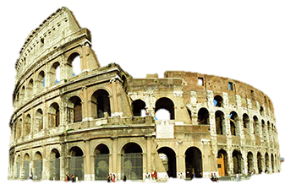
Roman Architecture
Adapted from Colleen Messina

¹ The Romans were great builders. Many things you see today have been inspired by ancient Rome. Even though they copied some things from the Greeks, the Romans had many original ideas.
² The Romans used arches extensively. An arch is a curved structure that can hold a lot of weight. Arches helped Roman architects a great deal. With arches, they could build over windows and doors. With arches, they could build huge structures called aqueducts. Aqueducts brought water to the city of Rome from the hills.
³ The Romans invented concrete. Concrete comes from lime and water. A Roman builder would make a mushy paste. Then he would add volcanic sand and pebbles. It could then be molded into whatever shape was needed. The concrete would dry and harden. It would never get soft again, even in the rain. Roman builders also made bricks out of baked clay. Bricks were used in many Roman structures. Each brick maker put his own special mark on his bricks. That would tell others who made the brick and where it came from.
⁴ The Romans used concrete to build an enormous structure called the Coliseum. It was named the Flavian Amphitheatre, and it held 50,000 people. Today, people all over the world call it the Coliseum.
⁵ If you could look down on the top, you would see that it looks like a circular football stadium. There is a big arena in the center and seats all around. The Romans enjoyed watching many kinds of fights there. Today, many of them seem cruel. They would be illegal now, but in ancient Roman times, thousands of people enjoyed these contests. Roman fighters, called gladiators, would fight to the death in the Coliseum. There were also events in which hunters hunted wild animals. Sometimes the arena was even filled with water for a sea battle. Other shows acted out land battles and ancient myths.
⁶ A large part of the Coliseum is still standing, and it is open for tours. If you visit Rome, you can see the stadium and imagine what it was like to be part of the crowd there. Look at the outside of the Coliseum. You see three tiers of arches circling around the huge building. Above that, there is a fourth level. On that top story there were masts that held up a giant canopy. It shaded the fans and still let a breeze pass through. Just like in a modern stadium, the seats for the fans circled around inside. The most important fans sat on the lower level close to the action. The everyday people sat higher up.
⁷ The arena in the center used to have a wood floor. It was covered with sand, and this is where the shows took place. That floor is no longer there. Below the arena floor there are two more levels. Since the floor is gone now, you can see into the rooms below. There were rooms for gladiators waiting to fight. There were rooms for wild animals. Gladiators and animals could be raised up on platforms. They would appear suddenly through trapdoors in the floor. There were even hoists to raise an elephant up to the stage.
⁸ The Romans also built thousands of miles of roads. These roads helped the army keep track of the vast Roman Empire. The roads were straight. Chariot wheels moved much more easily over paved roads than on muddy ruts. The Romans liked straight roads. They even went through cliffs so their roads could be straight. The Romans were great builders. Even fast food restaurants use ideas from the Romans! From arches to concrete, our modern world has been influenced by the architects of ancient Rome.

 | Roman Coliseum | Circus Maximus | Wrigley Field | United Center
Year built | 80 AD | 500 BC | 1914 AD | 1988 AD
Years used | More than 400 | Almost 1000 | 92 and counting | 17 and counting
Used for… | Gladiator fights, Naval battles, mock wars, prisoner and animal executions, speeches and plays | Chariot Races, foot races | Baseball (Cubs), Football (Bears and college football), Concerts | Basketball (Bulls), Hockey (Blackhawks), Shows, Concerts
Dimensions | 144 Feet tall | 700 Yards long | 135 feet high | 155 feet high
Seating | 55,000 and up (100,000 max) | 200,000 | 40,000 | 21,000
Levels of Seats | 4 | 2 | 2 | 3
Cover | Yes | No | No | Yes
Luxury Boxes | Yes | Yes | Yes | Yes
Extras | Had hundreds of statues, one in each arch of stadium. Floor changed for “naval” battles | Had 12 large starting gates for the chariots | Ivy covered walls, field changed for football | Remove hard floor for ice rink

- Which stadium is the oldest
  - Wrigley Field
  - United Center
  - Circus Maximus
  - Roman Coliseum

- Which stadium had the most uses?
  - Wrigley Field
  - United Center
  - Circus Maximus
  - Roman Coliseum
- Which stadium held the most people?
  - Wrigley Field
  - United Center
  - Circus Maximus
  - Roman Coliseum

- What did all the stadiums have in common?
  - They all had luxury boxes
  - They held over 20,000 people
  - Sports were played in each stadium
  - All of the above

Main Idea: “Roman Slavery”
YOUR GOAL: Accurately IDENTIFY the MAIN IDEA of the entire reading, PROVE that your answer is correct, and ASSESS YOURSELF to see how you’ve grown as a thinker.
After you read the passage, you will create a one-statement summary of the “Main Idea.”
Your statement should accomplish each of the following:
- It is a statement of YOUR creation (not copied from the passage itself).
- It represents the ENTIRETY of the passage rather than merely restating portions of the passage.
- It is a complete statement that gives the reader a sense of the author’s intention.
--good—“The policies of Barack Obama and George W. Bush are drastically different in many areas.”
--not so good—“It’s about the policies of Barack Obama and George W. Bush.”
“Roman Slavery”
(1) Some Roman people were owned by other people as slaves. Because the Romans didn't really have hourly wage work as we do now, men and women who didn't own their own land or businesses often found themselves enslaved. The jobs slaves did were jobs which today in the United States are done by free people working for wages. Like today, some of these jobs were awful, and some of them were pretty good.
(2) Many of these men and women, especially in southern France and Spain, worked in the fields on big farms owned by rich landowners. A slave or freedman overseer forced hundreds or thousands of slaves to work out in the fields all day under the sun, and at night the slaves slept in barracks, with the men separated from the women. In ancient times, perhaps as much as 90% of people or more of some communities worked solely in farming.
(3) Other slaves were forced to work deep underground in the mines, getting gold, silver, copper, iron, or tin for the Roman government. Most suffered and died after just a few years. Traders kept slaves to row ships, often chained to their oars. Many of these men were sentenced to the mines or to the ships because they were criminals.
(4) Other slaves were house servants for richer people - nannies, nurses, cooks, butlers, house-cleaners, stable-boys, laundry-women, tutors for children, accountants. These slaves often had families, though they could never be sure of keeping them. Children who were slaves were often sold away from their parents. Many slaves also worked in factories or craft shops. They might be weavers, or dyers, or potters, or mosaicists, for example. Some slaves worked in construction, while others worked for the Roman government as accountants or as guards.
(5) Many of these slaves were freed when they got older and became Roman citizens. They were known as freedmen and freedwomen. Not all slaves were freed, but if a slave was born from a woman owned by the master, he might free that child when they came of age, around 18 or so. The master might even give a small amount of money so that the slave could start a small or business or even get married and start a family.

PART 1: IDENTIFY THE MAIN IDEA
Remember: Main Ideas represent the ENTIRETY of a passage, not merely sections or specific examples.
DIRECTIONS: Create a main idea statement that represents the entirety of this passage.

PART 2: PROVE YOUR ANSWER
DIRECTIONS: Explain why you wrote this answer. Provide supporting details from the passage that led you to this choice.

PART 3: POST-DISCUSSION SELF ASSESSMENT
DIRECTIONS: On the line below, mark an “X” where you believe your main idea statement belongs.
PERFECT! _____________________________________________ COMPLETELY WRONG!

PART 4: METACOGNITION (“Thinking About Your Thinking”)
DIRECTIONS: Describe the most important lesson you learned from this activity. What will you do differently the next time we complete an activity like this one?

Vocabulary
Define the following terms in your own words:

Deities

Plebians

Patricians

Consul

Dictator

Peninsula

Freedman

Aqueduct

Orator

First Triumvirate

Second Triumvirate

Edict

Pax Romana

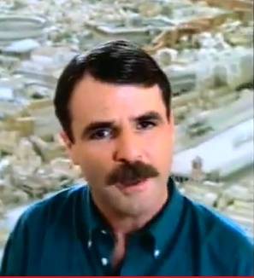
Roman City
David Macaulay

Answer the following questions as you watch the video:

- What is unique about the cities of Pompeii and Herculaneum?

- What was the “heart of the city?”

- How was a Roman city laid out?

- What was the city’s line of defense against attack?

- How did water reach the city?

- Why were the Gauls/Druids unhappy with Roman Rule?

- Why did larger Roman houses have courtyards?

- What was located on the ground floor of apartment buildings?

- What happened at the amphitheaters?

Making Comparisons: How is a Roman city similar to our cities today? How were they different?

Lesson: 5 | Topic: Roman Personalities
Standards: | Learning Outcomes:  - Develop understanding of Roman leaders and their contributions to Roman history.
Activities
Activity 1: Opener question—What makes a strong leader? What does a strong leader need to do to keep power/peace? Discuss the opener as a class as a lead-in to learning about Roman leaders of the Republic.

Activity 2:
- Class reading of “Hannibal Barca”
- Students answer questions and compare as a class to check for understanding

Activity 3:
- Class will view short video clip on Hannibal/crossing of the Alps: “True Story of Hannibal the Great, Part III” http://www.youtube.com/watch?v=bFNGVSf7YNM (~10 min)
- Narrative writing (15 min): Do you think Hannibal right to attack Rome? Why or why not?

Activity 4: Begin reading Supporting Details/Linking “Julius Caesar” and finish for homework.

Materials Needed:  - “Hannibal Barca”  - Video clip of Hannibal  - SD/L “Julius Caesar” | Assessments:  - Reading questions  - Narrative response

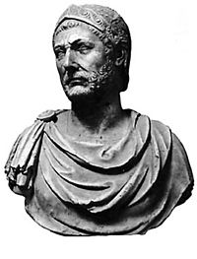
Hannibal Barca
Adapted from Vickie Chao
¹ Back in the 3rd century B.C., the Roman Republic was expanding at an alarming rate. So was the Carthaginian Empire (or Carthage for short) on the other side of the Mediterranean Sea. As the two regional powerhouses rushed to build up their presence, a conflict was bound to happen. The first showdown between the Romans and the Carthaginians, called the First Punic War, broke out in 264 B.C. and lasted for 23 years. In the end, the Carthaginians lost. They ceded control over Sicily Island to the Roman Republic and paid it a substantial amount of indemnity.
² Five years after the conclusion of the First Punic War, a forceful Carthaginian general by the name of Hamilcar Barca decided to push his country's territory beyond the confines of North Africa and develop a military base in Hispania (Spain). He e took his eldest son, Hannibal Barca, with him. He wanted the little boy to swear that he would make the Roman Republic his enemy for life. Hannibal, who was only about nine years old at the time, took the oath and never broke it.
³ Hamilcar, by all accounts, was a great general. Under his leadership, the Carthaginians quickly gained footholds in Hispania. During his nine-year stay there, he fought numerous battles and kept pushing his troops northward. After he got killed in combat, his son-in-law, Hasdrubal, became the new military chief. He wanted peace and even signed a treaty with the Romans. For the next seven years or so, the two archenemies tolerated each other, more or less. This delicate balance finally tilted after a Celt assassinated Hasdrubal in 221 B.C. Upon Hasdrubal's untimely death, the Carthaginian armies in Hispania hailed Hannibal as their commander. This young military chief decided to provoke the Romans. He knew that Saguntum, an independent city-state, had a very good relationship with the Roman Republic. He wanted to use that to his advantage. In 219 B.C., he launched a series of attacks against Saguntum and barricaded it for nearly eight months. During the siege and the looting afterwards, the Roman Republic protested fiercely. It sent an envoy to see Hannibal. It also sent an ambassador to Carthage, demanding the Carthaginian government to hand Hannibal over. When both meetings went nowhere, the Romans declared war in 218 B.C. That war was called the Second Punic War.
⁴ After the onset of the war, Hannibal showed no intention of fighting the Romans in Hispania. He wanted to fight them on their turf -- Italy. So in the spring of 218 B.C., he took nearly 50,000 soldiers and several war elephants with him and left for Italy. To surprise the Romans from a place where they expected it the least, Hannibal did the unthinkable. He crossed the Alps, the highest mountain range in Europe! The march was extremely difficult. Before even getting to the Alps, Hannibal had to battle against many hostile tribes along the way. When he finally reached the foot of the Alps, it was already late autumn. Winter was fast approaching. Eager to take down the Roman Republic as soon as possible, Hannibal urged his men to keep going. The crossing turned out to be a big disaster. Many of his soldiers died because of the harsh weather. After trekking for nearly two weeks, Hannibal finally managed to take his force down the Alps. The entire journey took a big toll on the battalions. By the time they reached the ground, Hannibal had lost nearly half of his men and most of his elephants.
⁵ Shortly after invading Italy, Hannibal scored a major victory against the Romans. In the Battle of Ticinus in November 218 B.C., Hannibal defeated and severely wounded a Roman general named Scipio. The triumph gave the Carthaginians a boost in confidence. It also won them support from some of the Roman Republic's allies. The Romans sent more soldiers. But since they were not nearly as competent in fighting as Hannibal's men were, they were doomed to fail. In December 218 B.C., Hannibal won the Battle of the Trebia River. Then in March 217 B.C., he won the Battle of Lake Trasimene.
⁶ Despite the repeated defeats, the Roman Republic again called for more troops (80,000 this time), hoping that sheer volume alone would be enough to stop Hannibal's advance for good. It was wrong! Hannibal understood very well how the Romans fought. He knew that the Romans liked to march forward. He would let them do that by pretending to withdraw. In the meantime, he would send a portion of his troops to spread out and encircle the enemy. Once the trap was set, the onslaught could begin. On August 2, 216 B.C., the two sides met in Cannae. Just as Hannibal had predicted, the Romans marched forward and went straight into his trap! After days of killing, nearly 50,000 Romans died. It was the worst defeat ever in ancient Rome's history!
⁷ After the Battle of Cannae, the Romans finally realized that they had underestimated Hannibal all along. Now, because of their ignorance, this forceful Carthaginian general roamed through Italy. He captured and sacked one city after another, and many of the Roman Republic's alliances began to shift their positions. Terror loomed over the entire nation like a dark cloud. Nobody knew what would happen next. Nobody knew if Rome would be able to withstand Hannibal's assault. Amazingly, in spite of all the uncertainties, the Roman Republic refused to negotiate with Hannibal. Its new strategy was to avoid open conflicts. With only about 50,000 men at his disposal, Hannibal could not possibly attack Rome while holding on to all the cities he just bagged. To make matters worse for this great general, the Carthaginian Empire turned down his request for more reinforcement troops. For the next thirteen years, Hannibal stayed in Italy and continued to harass its residents.
⁸ While Hannibal chose to remain in Italy, the Roman Republic sent Scipio (son of the Roman general Scipio who lost the Battle of Ticinus in 218 B.C.) to capture Hispania. The idea was to intimidate the Carthaginian Empire, forcing it to call Hannibal back. Scipio arrived at Hispania in 210 B.C. and quickly took over. Scipio then turned to North Africa in 205 B.C. Once the force landed, they again made swift progress and the Carthaginian government demanded Hannibal’s return. When Hannibal learned of the invasion, he was torn. On one hand, he resented his fellow countrymen for not giving him the badly needed reinforcement troops several years earlier. On the other hand, he was patriotic and felt duty-bound to defend his nation. In the end, he chose to go back. He arrived at North Africa in 203 B.C. and had a showdown with Scipio the following year. In the fateful Battle of Zama, Scipio stunned Hannibal with his newly improved force and defeated him soundly. After the bloody conflict, the Roman Republic and the Carthaginian Empire made a truce and ended the Second Punic War (218 B.C. - 201 B.C.)
⁹ From 201 B.C. to 195 B.C., Hannibal temporarily gave up his military life and became a statesman. He soon proved that his ability to govern was as good as his ability to fight. He carried out numerous reforms, and all those measures made him very popular. Seeing his success, other Carthaginian politicians were jealous. They conveniently forgot that they had refused to help Hannibal all those years ago and accused him now of not taking down the Roman Republic. As the tension escalated, some in the Carthaginian government even suggested turning Hannibal over to the Roman Republic. Saddened by the betrayal, Hannibal packed his bags and left his homeland. He never returned.
¹⁰ After leaving the Carthaginian Empire, Hannibal became a free-agent general. He offered his service to anybody who hated the Romans. For years, he drifted from one country to another, making a career out of fighting the Roman Republic. Needless to say, the Romans hated Hannibal. As they were closing in on him, Hannibal swallowed poison and killed himself. He is believed to have died in 181 B.C.
Hannibal Barca

- Which of the following about Hannibal is correct?
  - He started the First Punic War
  - He was a great general, but a horrible politician
  - He captured and sacked Rome in 218 B.C.
  - He vowed to fight the Romans since he was 9 years old.

- Which battle was the Roman Republic’s worst defeat ever in their history?
  - The Battle of Cannae
  - The Battle of Lake Trasimene
  - The Battle of Ticinus
  - The Battle of Zama

- For how many years did the Second Punic War last?
  - 17 years
  - 12 years
  - 35 years
  - 23 years

- Why did Hannibal leave the Carthaginian Empire in 195 B.C.?
  - Because he found a better job elsewhere
  - Because he was bored
  - Because his fellow countrymen betrayed him
  - Because he wanted to take his force to cross the Alps and invade Italy

- Why did Hannibal go back to North Africa in 203 B.C.?
  - Because he wanted to visit his family
  - Because he wanted to run for an election
  - Because he wanted to defend his nation
  - Because he wanted to recruit more soldiers

- What can you infer about the way Hannibal died?
  - He was getting old and wanted to make it quick
  - Hannibal was depressed about being away from Carthage and his family
  - The last thing he wanted in life was to get caught by the Romans
  - He was tricked and poisoned by one of his soldiers

- Put the following events in order in which they happened.
    - The First Punic War Ended
    - Hannibal crossed the Alps
    - Scipio battled Hannibal in Africa
    - Romans and Carthaginians made a truce

- i, ii, iii, iv
- i, iv, ii, iii
- iii, iv, ii, i
- iv, ii, i, iii

YOUR GOAL: IDENTIFY the statements that serve as SUPPORTING DETAILS for the thesis statement:
Supporting Details/Linking: “Julius Caesar”
Remember: Supporting Details are not merely true statements or words that are present in the reading; they provide support for an argument (MAIN IDEA) to persuade the reader.
Directions:
A. For each statement, choose one of the following.
- The statement provides support for the thesis.
- The statement refutes the thesis.
- The statement neither supports nor refutes the thesis.
B. Mark the appropriate column with an “X.”
THESIS: Julius Caesar was one of the most important Roman leaders.
Statement | Supports | Refutes | Neither
- Though Caesar’s family belonged to the first category, they had lost their fame and fortune a long time ago.
- Caesar won many battles and became known for his military genius.
- His tough stand on crime won him lots of support from the commoners.
- Caesar decided to remarry in 67 BC for political gain.
- Using his brilliance, he conquered many lands and helped to expand the Roman Republic’s already vast territory.
- By 48 BC, the Senate appointed him dictator and gave him total control of Rome.
- The two [Caesar and Cleopatra] reportedly had an affair.
- With his power reaching an all-time high, Caesar minted coins bearing his face.
- On March 15, 44 BC, they [Senators] stabbed him in a gathering and laid his body at the foot of Pompey’s statue.
- Caesar, in the eyes of many, was a controversial figure.

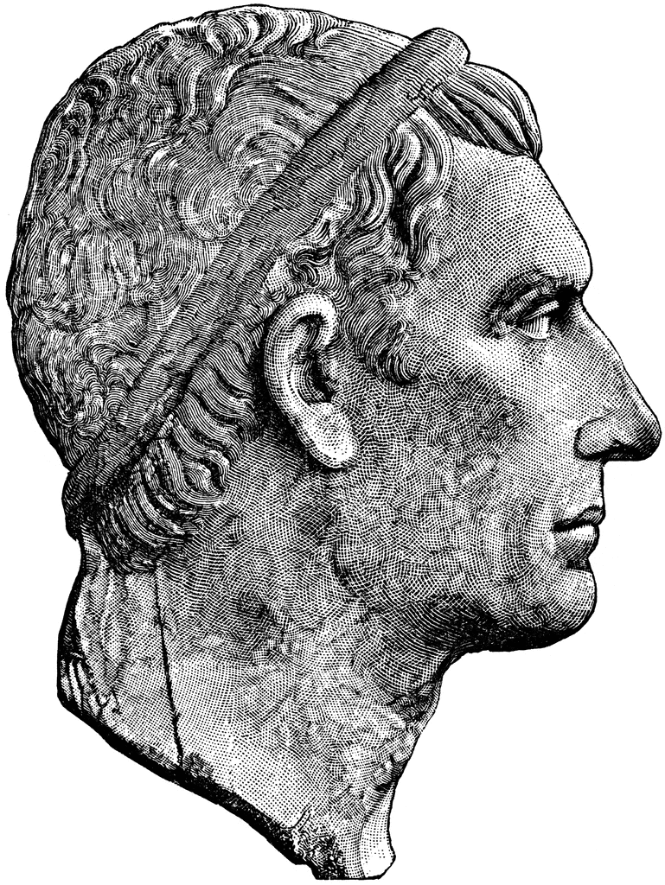
Julius Caesar
By Vickie Chao

¹ Ancient Rome had many famous people. Julius Caesar, undoubtedly, was one of them.
² Julius Caesar was born on July 13, 100 B.C. (some say 102 B.C.) At the time, the Roman society divided its citizens into two large groups. One was for the nobles. The other was for the commoners. Though Caesar's family belonged to the first category, they had lost their fame and fortune a long time ago. The harsh reality forced them to live in an apartment house in a less reputable area in Rome.
³ Luckily, all hope was not lost. When Caesar was about 10 years old, his aunt, Julia, married a very rich man named Gaius Marius. Through him, the financial woes that the Caesars had suffered earlier became a memory of the past.
⁴ Marius started out his career in the army before pursuing a political life. Politicians in ancient Rome all had one position in mind - consul, and Marius was no exception. He won his first consul election in 108 B.C. and then five more times. After concluding his sixth term in the office, he announced his intention to retire. When he heard that his archenemy, Lucius Cornelius Sulla, was preparing for the war against the king of Pontus in Asia Minor (today's Turkey) in 87 B.C., he decided to come out of his retirement. He convinced the senate that he was a better candidate for the job than Sulla.
⁵ As the news of switching commandership reached Sulla, he was very angry. He led his troops back to Rome and forced Marius and his supporters to flee. With Rome now under Sulla's control, he took back the right to lead the military campaign against Pontus and departed once again. After Sulla was gone, Marius returned to Rome. Teamed up with Lucius Cornelius Cinna (Caesar's father-in-law), the duo persecuted Sulla's supporters. After Marius died, Cinna became the effective ruler of Rome for the next couple of years. He died in 82 B.C.
⁶ Upon Cinna's death, Sulla made a triumphant return to Rome. He secured an appointment from the senate and became dictator in 81 B.C. With things going his way now, Sulla began his revenge. He proscribed and outlawed anybody who opposed him. As Marius' nephew by marriage and Cinna's son-in-law, Caesar was an obvious target. To save his own life, he put on a disguise and went into hiding outside of Rome. His relatives and supporters persuaded Sulla to change his mind and spare Caesar.
⁷ In spite of Sulla's pardon, Caesar did not return to Rome. He joined the military and stationed in Asia Minor until Sulla died in 78 B.C. Caesar won many important battles and quickly became known for his genius in military operations. After Sulla's death, he came back to Rome and began trying his hands as a politician.
⁸ Caesar, by all accounts, was a great orator (public speaker). As a legal advocate, he prosecuted former governors notorious for extortion and corruption. His tough stand on crime won him lots of support from the commoners. For the next few years, Caesar took one position after another and slowly climbed up the political ladder. It is said that he once saw a statue of Alexander the Great and wept. When asked why he was so upset, he said that when Alexander was his age, he already had conquered so many nations. He felt ashamed because he had done nothing memorable to speak of. As if the realization was not depressing enough, he soon got two more blows in his personal life. Both his beloved wife and Aunt Julia died! Alas, 69 B.C. was indeed a difficult year for Caesar.
⁹ Though stricken by his personal loss, Caesar decided to remarry in 67 B.C. for political gain. This time,he chose Sulla's granddaughter but hey divorced five years later.
¹⁰ Caesar was an extravagant spender. Over the years, he had accumulated a lot of debts. His personal financial crisis reached a boiling point by 63 B.C. He eventually had to rely on his friends to pay off some of his balance. While stationed away place from Rome, Caesar developed a remarkable reputation as a military commander. He fought and won numerous battles against the rebellious local tribes. Upon his triumphant return to Rome, he decided to run for the office of consul. To achieve his goal, he decided to seek help from Marcus Licinius Crassus and Gnaeus Pompeius Magnus ("Pompey the Great"). With much negotiation, the trio set up an alliance (later became known as "The First Triumvirate," or “rule of three”). In their deal, Crassus and Pompey used wealth and influence to help Caesar win the election, and once elected, Caesar lobbied for their political interests. To further strengthen the bond, Caesar allowed Pompey to marry his daughter, Julia Caesaris. Crassus, Pompey, and Caesar's arrangement worked out beautifully. Caesar became consul in 59 B.C. True to his words, he helped champion the causes beneficial to Crassus and Pompey. Caesar married for the third time during his one-year term in office.
¹¹ After Caesar finished serving as consul, he spent most of his time in the next couple of years outside of Rome. Using his brilliance, he conquered many lands and helped to expand the Roman Republic's already vast territory. Among his achievements during this period, the most famous were perhaps the two invasions of Britain - first in 55 B.C. and second in 54 B.C.
¹² Despite the success, Caesar had a lot of problems on his hands. Many people in Rome disliked him. They would pounce on any chance to take him down. Of his two staunch supporters from the First Triumvirate, Crassus was dead, and Pompey began to develop a different view of Caesar after he lost his wife Julia Caesaris in childbirth in 54 B.C. Caesar tried to mend the relationship with his opponents. But nothing worked. In early January of 49 B.C., the senate declared him a public enemy. When word reached Caesar, he set out to prepare for war. At the dawn of January 11, he and his men arrived at the northern bank of a small river called Rubicon that marked the official border of the Roman Republic. Right before crossing, he ordered his troops to halt and contemplated his options. If he proceeded, he would trigger a civil war and really make himself a public enemy. If he pulled back, he would face persecution and, most likely, lose his life. Seeing no way out, he marched forward and invaded his own country.

¹³ The victory came swiftly. By 48 B.C., the scared senate appointed him dictator and gave him total control of Rome. Pompey fled to Egypt seeking refuge but was ultimately killed. Caesar lingered in Egypt for several months. During his stay there, he defeated the pharaoh and installed Cleopatra VII as the new ruler in Egypt. The two reportedly had an affair.
¹⁴ Caesar left Egypt in 47 B.C. to quash the remaining rebellion forces. Upon his return to Rome, the senate showered him with praise and honors. It appointed him dictator for the next 10 years. It allowed him to hold any public office he wanted. It renamed the month of his birth from Quintilis to July (or Julius in Latin). It made his birthday a national holiday. With his power reaching an all-time high, Caesar minted coins bearing his face. The act was the first in the Roman history, for no living Roman had ever had his image featured on coins. Furthermore, a statue of Caesar with the inscription "To the Invincible God" was put up in the capital.
¹⁵ In 45 B.C., Caesar was made dictator for life. His influence made many senators very uncomfortable. The spirit of the Roman Republic was to avoid having any one person with absolute control. That is, the spirit of the Roman Republic was to avoid monarchy. As Caesar began to act and to be looked upon as the king, the discontented senators decided to do something about it. On March 15, 44 B.C., they stabbed him in a gathering and laid his body at the foot of Pompey's statue.
¹⁶ Caesar, in the eyes of many, was a controversial figure. While several of his policies made him immensely popular among the commoners, he always had a strained relationship with the nobles who eventually had him killed. From the time of his death until now, he has continued to be hailed as one of the greatest commanders in history. His military achievement was as exceptional as that of Alexander the Great!

Lesson: 6 | Topic: Roman Entertainment
Standards: | Learning Outcomes:  - Develop understanding of Roman leaders and their contributions to Roman history.  - Discover Roman entertainment.
Activities
Activity 1: Opener question—What do you do for fun/recreation? What do you think most Americans enjoy for entertainment?

Activity 2:
- Finish class reading of Supporting Details/Linking “Julius Caesar” and complete questions in partners. Teacher will check responses for understanding.

Activity 3:
- Class will view short video clip from Ben-Hur depicting the chariot race (~10 min).
- In partners, students read “Gladiators” and answer the questions.
Activity 4:
- Class compiles a review list on the board of the daily life activities in Ancient Rome (i.e. bathing, dinners, politics, gladiatorial games)
- Students respond to the narrative prompt: There is a famous phrase, “When in Rome, do as the Romans do.” If you lived in Ancient Rome, how would you act?

Materials Needed:  - “Gladiators”  - Video clip of Ben-Hur chariot race  - SD/L “Julius Caesar”  - MEL-Con web for narrative | Assessments:  - Reading questions  - Narrative MEL-Con

Gladiators
¹Back in the old days of Rome, people loved to see gladiators fight. Gladiators were professionally trained warriors. Their job was not to defend the nation, but to battle against each other in public. To the onlookers, such combats were fun and exciting. But to gladiators, they were not. Every time they marched to the center of an arena for a match, they put their lives on the line. If they made one false move, they could easily get injured or worse, face the most horrible outcome of defeat - death!
² While Ancient Rome was famous for this brutal form of sport, it did not invent it. The credit should really go to the Etruscans. The Etruscans believed that when an important man died, his spirit needed a human sacrifice to survive the afterlife. To honor the deceased, they would stage a battle at the man's funeral. As the loser lay dying on the ground, his body became a burial offering.
³ The Etruscans ruled Rome for about a century. Historical records show that the first gladiator fight in Rome occurred in 264 B.C., long after the Etruscans were gone. That display was for honoring a man named Brutus. At his funeral, his sons held a contest among three pairs of gladiators. The fight must have gotten a lot of buzz around the town. Slowly, it took root in Rome and became a popular sport. With more and more people watching the game, the scale of it grew bigger over time. It went from the initial three pairs to three hundred, and then to five thousand!
⁴ For the most part, gladiators were usually criminals, slaves, or prisoners of wars. They were sent to special schools called ludi. Once there, they had to learn how to use weapons. Upon "graduation," they each would be assigned to a specific class. The class would later dictate the type of weapon a gladiator could use. For example, in a gladiator game, the organizer would pit a fight between a "net man" and a "pursuer." The former had only a net in his right hand and a dagger in his left. The latter came fully armed. As the two warriors faced each other in the arena, the "net man" would try his best to cast the net over the "pursuer." If he managed to do that, he could then use his dagger to kill the opponent.
⁵ Of course, death was the most common outcome of a gladiator fight. But it was not the only one. When a gladiator was wounded, he could raise his forefinger to beg mercy from the audience or the high-ranking officials at the game. If they wanted to spare his life, they turned their thumbs up or waved their handkerchiefs. If they wanted to slay him, they turned their thumbs down or toward their chests. Usually, the audience's response was enough to determine the fate of the wounded gladiator. However, the final decision was always in the hands of the emperor (if he was there) or the game organizers.
⁶ Each time he entered a game, a gladiator knew very well that it could be his last. Each time he made the pledge "We who die to salute you!" at the onset of a game. If a gladiator was lucky enough to win enough combats, he could receive a discharge from further service. A successful gladiator enjoyed fame and fortune though Romans looked down on them for their shameful backgrounds. The Roman public followed the sport wholeheartedly. They cheered on their favorite contestants and even depicted them in poems and paintings.
⁷ Gladiator fights fell into disfavor during the fourth century. Emperor Constantine I issued an edict (ruling) in 325 A.D. and officially banned the sport but for the next several decades the Romans continued to hold gladiatorial games. They did not give up this entertainment until Emperor Honorius came along and banned the sport again in 393 A.D. This time, he made sure that his order was taken seriously. The last known gladiator fight in Rome was on January 1, 404 A.D. After that, it faded into history and became a thing of the past!
- Who were the least likely to become gladiators
  - Nobles
  - Criminals
  - Prisoners of war
  - Slaves

- What was the original purpose of staging a gladiator fight?
  - To honor the dead
  - To celebrate a new year
  - To show off wealth
  - To please the gods

- Based on paragraph 1, which of the following statements is false?
  - Gladiators were professionally trained warriors
  - Everyone thought Gladiator battles were fun and exciting
  - Injury or death could occur to a gladiator anytime they entered the arena
  - Gladiators were not trained to defend Rome.

- According to the 4th paragraph, what does the word ‘ludi’ mean?
  - Gladiators were typically criminals or slaves
  - Special schools in which gladiators were trained
  - It’s the graduation ceremony for gladiators
  - The organization of gladiators into groups

- For how many years did Rome have gladiator fights?
  - 843 years
  - 140 years
  - 668 years
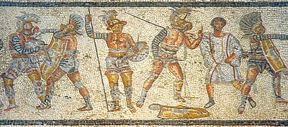
  - 385 years

- Which of the following statements accurately depicts a gladiator’s life?
  - Gladiators were all hailed as heroes and celebrities
  - Some Romans despised them, others admired them
  - Most Romans thought gladiators lived a fun and exciting life.
  - Emperors Constantine and Honorius celebrated the lives of gladiators

- The main idea of the 3rd paragraph is: “The first gladiator fight in Rome was in honor of the death of Brutus.”

Which of the following statements supports the main idea of the paragraph?
  - The Etruscans ruled Rome for about a century.
  - The Etruscans first held gladiator events as a sacrifice to honor their dead.
  - At his funeral, his sons held a contest among three pairs of gladiators.
  - More and more people began watching the sport in Rome

- What is the main idea of paragraph 6?
  - Gladiators were well respected by nearly all Romans
  - Gladiators lived a life filled with turmoil and sacrifice
  - Gladiators were tough, but had families that loved them.
  - Gladiators lived a depressing life of death and shame.

Lesson: 7 | Topic: Roman Empire
Standards: | Learning Outcomes:  - Develop understanding of how Rome changed from a Republic to an Empire
Activities
Activity 1: Opener question—Is there good that can come out of seeking revenge against somebody else? Explain.

Activity 2:
- Review the history of Julius Caesar as a class.
- Class reading of “Augustus Caesar” and completion of questions in groups

Activity 3:
- Partner reading of “Where are Antony and Cleopatra?” and completion of questions.
- Class reviews selected questions to check for understanding.
Activity 4:
- Introduction of “No Place Like Rome” advertisement project. Students will be provided paper and materials to use in class but encouraged to use time outside of class to complete their advertisement.

Materials Needed:  - “Augustus Caesar” reading  - “Where are Antony and Cleopatra?”  - “No Place Like Rome” project | Assessments:  - Reading questions  - Advertisement product

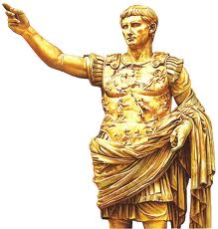
Augustus Caesar: The Empire is Born
¹For Ancient Rome, 27 BC was a defining moment. That year, the Republic ceased to exist. In its place, the Empire was born, and Augustus was its first emperor.
²His rise to power was a lucky one, for he had a powerful uncle—none other than Julius Caesar. Caesar took Augustus, known then as Octavian, under his wing and taught him to be a soldier and politician. Impressed by the boy’s potential, Julius Caesar adopted Augustus as his son and successor. Not long afterwards, in 44 BC, Caesar was assassinated in the Senate building. Augustus quickly gained the support of his uncle’s troops, though he was only 18.
³In the power struggle that followed, few took Augustus seriously because of his young age. At the time, Mark Antony (Caesar’s right-hand man) and Cicero (a Senator) were competing for power. Cicero ridiculed Augustus publically, which led Augustus to form an alliance with Antony; together with Marcus Aemilius Lepidus, they formed the Second Triumvirate and gained control of Rome. Immediately afterward, they unleashed their revenge on Rome for Caesar’s assasination, killing an estimated 300 Senators and 2,000 noblemen. Cicero’s fate was the worst. He was caught escaping and killed on Dec. 7, 43 BC. His head and hands were severed and put on public display at the Forum in Rome. Antony’s wife is said to have pulled out Cicero’s tongue and jabbed it with a hairpin in defiance against Cicero’s power of speech.
⁴The Second Triumvirate kept Mark Antony, Augustus, and Lepidus united until they had avenged Caesar’s death. Antony and Augustus could not get along, and when Lepidus died and Antony decided to leave his wife and go to Egypt to be with Cleopatra. Antony set up a will to appoint Caesar’s biological son, Caesarion, the rightful heir to Caesar’s power. When Augustus got word of this betrayal, he stole the document and used it as proof that Antony no longer cared about Rome and its traditions. Augustus persuaded the Senate to declare war on Antony and Cleopatra. When the two sides fought, Augustus was victorious. Antony and Cleopatra fled to Egypt where they committed suicide together.
⁵Augustus took over Egypt and had Caesarion killed so nobody else would could claim to be Caesar’s heir. At the age of 33, Augustus had defeated every opponent of the Republic. As the most powerful man in the world, Augustus knew he must not rush to consolidate his power and get rid of the Senate as Caesar had. Instead, he served as Consul for several years but kept control of Rome’s strong military. His power influenced the Senate, who gave Augustus supreme power and the title “First Citizen.” He was effectively then the first emperor of Rome. He led campaigns that greatly expanded and enriched the Republic, and his rule heralded an era of peace and prosperity known as Pax Romana. When Augustus died in 14 AD, his last words were "I found Rome of clay, and leave her to you of marble." He had found Rome as a Republic, and left it an Empire.
PART 1: IDENTIFY THE MAIN IDEA
Remember: Main Ideas represent the ENTIRETY of a passage, not merely sections or specific examples.
DIRECTIONS: Create a main idea statement that represents the entirety of this passage.

PART 2: PROVE YOUR ANSWER
DIRECTIONS: Explain why you wrote this answer. Provide supporting details from the passage that led you to this choice.
Why:
Supporting Detail:
Supporting Detail:
Supporting Detail:
Supporting Detail:

PART 3: POST-DISCUSSION SELF ASSESSMENT
DIRECTIONS: On the line below, mark an “X” where you believe your main idea statement belongs.
PERFECT! _____________________________________________ COMPLETELY WRONG!

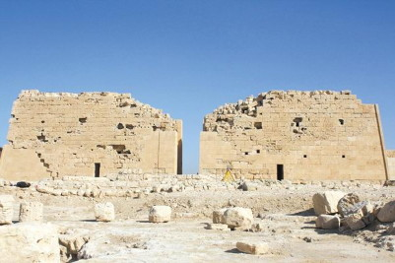
Where Are Antony and Cleopatra?
CAIRO, Egypt (Achieve3000, August 27, 2009). An archaeologist in Egypt believes he may have discovered the long-lost tomb of Antony and Cleopatra.
Egypt's top archaeologist, Zahi Hawass, believes that Antony and Cleopatra, two legendary rulers of antiquity, are buried inside a 2,000-year-old Egyptian temple called the Taposiris Magna. The partially excavated temple is located near the Mediterranean Sea, about 30 miles from Egypt's ancient seaside capital of Alexandria, where Cleopatra is known to have resided.
A view of Osiris temple at Taposiris Magna, Alexandria
While the precise location of Antony and Cleopatra's final resting place has long been a mystery, historians do know—thanks to Greek writer and historian Plutarch—that the two were buried together.
General Antony was a ruler of Rome, and Cleopatra was the queen of Egypt. Their deaths in 30 BCE (Before the Common Era) followed the defeat of their united armies during a clash involving Caesar Augustus, who had challenged the two rulers for complete control of the Roman Empire. According to Plutarch, Caesar permitted the pair to be entombed together.
So did Caesar have Antony and Cleopatra buried in the Egyptian temple, as Hawass believes? Hawass concedes that archaeologists are not "100 percent" certain that Antony and Cleopatra are entombed there. However, he says that excavation work has unearthed a great deal of evidence supporting his theory. Inside the temple, archaeologists have thus far discovered 22 coins bearing Cleopatra's name and face. They have also found various carvings that appear to be representations of the famous pair. In addition, a fragment of a mask with a cleft chin has been found.
"If you look at the face of Mark Antony, many believed he had this cleft on his chin," said Hawass. "That's why I thought this could be Mark Antony."
For Hawass, the most compelling evidence supporting his theory is the discovery of a cemetery encircling the temple. The cemetery contains at least 10 mummies. These mummies are from the same period as the artifacts found inside the temple. The placement of the cemetery indicates that someone of great importance was laid to rest inside the temple.
"The discovery of the cemetery [has] really convinced me that there is someone important buried inside this temple," Hawass said. "No one would be buried outside a temple without a reason. We saw that in the pharaonic days; they were always buried beside pyramids," he said.
Kathleen Martinez, an archaeologist from the Dominican Republic, has studied the life of Cleopatra for 12 years. Martinez has participated in excavations at the temple with Hawass for the last three years. Hawass credits Martinez for originally suggesting that Antony and Cleopatra's tomb might be located inside Taposiris Magna.
"I believe it could be [inside] Taposiris Magna because it was the most sacred temple of its time," Martinez said.
Hawass' claim about what lies inside the temple is the latest in a long line of spectacular assertions, many of which have been met with skepticism and bemusement—at least initially—by experts of Egyptian antiquities. But Hawass has been associated with many impressive discoveries. These include the Valley of the Golden Mummies, the mummy of the Egyptian Queen Hatshepshut, and others.
Hawass is confident that he will soon add the tomb of Antony and Cleopatra to his list of significant finds. He is now studying the temple using ground-penetrating radar, which has thus far revealed three possible sites of subterranean burial chambers located 40 feet underground. Excavations are now in progress to determine whether the bodies of the two rulers, long thought lost forever, are indeed buried within one of these chambers.
"In my opinion," Hawass enthused, "if this tomb is found, it will be one of the most important discoveries of the 21st century."
The Associated Press contributed to this story.

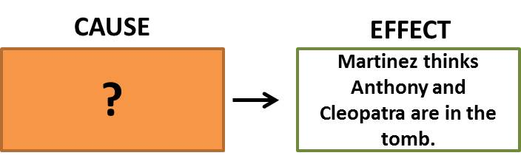
1. Which cause best fits the box above?
a) Martinez has studied the life of Cleopatra for the last 12 years.
b) Martinez has helped with excavations at the Taposiris Magna for three years.
c) The Taposiris Magna was the most sacred temple of its time.
d) The Taposiris Magna is located near the ancient city where Cleopatra lived.
2. Which is the closest synonym for the word bemusement?
a) Sarcasm
b) Puzzlement
c) Optimism
d) Adversity
3. The reader can infer from the article that __________.
a) Important leaders were buried with material possessions in ancient times.
b) Archaeologists are sure that Antony and Cleopatra were buried inside Taposiris Magna.
c) Hawass has yet to examine the fragment of a mask with a cleft chin that was found.
d) Greek historians have yet to release information about Antony and Cleopatra.
4. In the fifth paragraph, the author's primary point is __________.
a) Various items found in the temple support Hawass' theory that Antony and Cleopatra are buried there.
b) Hawass has admitted that archaeologists are not 100 percent certain if the long-lost tomb is in the temple.
c) Many coins were created in ancient times that displayed the name and face of Queen Cleopatra.
d) Antony was known to have a cleft on his chin, just like the one on the mask found in the temple.
5. Which of these should not be included in a summary of this article?
a) Martinez is an archaeologist from the Dominican Republic who studies Queen Cleopatra.
b) Excavations are in progress to find out if Antony and Cleopatra's tomb is in the temple.
c) Hawass believes he has discovered Antony and Cleopatra's tomb in the Taposiris Magna.
d) Archaeologists found items associated with Antony and Cleopatra at Taposiris Magna.
6. The article states: "I believe it could be [inside] Taposiris Magna because it was the most sacred temple of its time," Martinez said. Which would be the closest synonym for the word sacred?
a) Serene
b) Revered
c) Enriched
d) Ornate
7. The news article says all of the following except __________.
a) Archaeologists found carvings that appear to be representations of Antony and Cleopatra.
b) Historians say that Cleopatra resided at the Taposiris Magna before she died.
c) The location of the tomb of Antony and Cleopatra has long been a mystery.
d) The Taposiris Magna is a partially excavated temple located near the Mediterranean Sea.

Lesson: 8 | Topic: Roman Primary Sources
Standards: | Learning Outcomes:  - Analyze primary sources to draw conclusions about Roman society and culture.
Activities
Activity 1: Opener question—What can we gain from reading a primary source?

Activity 2:
- Complete “Ancient Rome: Analyzing Primary Sources” as a class.

Activity 3:
- Class time is given to work on “No Place Like Rome” project
Materials Needed:  - “Analyzing Primary Sources” worksheet  - “No Place Like Rome” project | Assessments:  - Primary source questions  - Advertisement product

Ancient Rome: Analyzing Primary Sources

Polybius, on the character of Hannibal
“Some cities again he made up his mind to treat with treacherous violence, removing their inhabitants to other cities, and giving their property up to plunder…these movements were accompanied by robberies of money, murders, and violence, on various pretexts at the hands of the outgoing or incoming soldiers in the cities.”

Speaker:

Occasion:

Audience:

Purpose:

Synthesis (finish this statement): The quote about Hannibal reflects his character as…

Plutarch, on the assassination of Julius Caesar
“And by this time, finding himself struck by a great many hands, and looking around about him to see if he could force his way out, when he saw Brutus with his dagger drawn against him…gave up his body to their blows. And they so eagerly pressed towards the body, and so many daggers were hacking together, that they cut one another…”

- Speaker:

- Occasion:

- Audience:

- Purpose:

- Synthesis (finish this statement): According to Plutarch, the actions of the Senators were…

Tacitus, on Augustus Caesar
“Augustus won over the soldiers with gifts, the populace with cheap corn, and all men with the sweets of repose.”
- Speaker:

- Occasion:

- Audience:

- Purpose:

- Synthesis (finish this statement): This quote by Tacitus shows that Augustus gained power by...

Playwright Plautus, on slavery in Rome
“There was no high motive for a slave to behave himself---simply a fear of cruel punishment if he did not. There might be a hope of ultimate freedom, but that depended entirely on the caprice of the master.”

- Speaker:

- Occasion:

- Audience:

- Purpose:

- Synthesis (finish this statement): The life of a slave was…

Microbius, describing a Roman feast
“Before the dinner proper came sea hedgehogs; fresh oysters, as many as the guests wished; large mussels…field fares with asparagus; fattened fowls; oyster and mussel pasties; black and white sea acorns…boar's ribs; fowls dressed with flour; becaficoes [songbird]; purple shellfish of two sorts. The dinner itself consisted of sows' udder; boar's head; fish-pasties; boar-pasties; ducks; boiled teals; hares; roasted fowls; starch pastry; and Pontic pastry.”

- Speaker:

- Occasion:

- Audience:

- Purpose:

- Synthesis (finish this statement): This meal is different from dinners I eat because…

Plutarch, on the Temple of Mars in Rome
“His temple at Rome has two gates, which they call the Gates of War, because they stand open in the time of war, and shut in the times of peace; of which latter there was very seldom an example.”
- Speaker:

- Occasion:

- Audience:

- Purpose:
- Synthesis (finish this statement): The role of gods in Roman daily life was…
Name: _________________________________

“No Place Like Rome!”
Poster Project

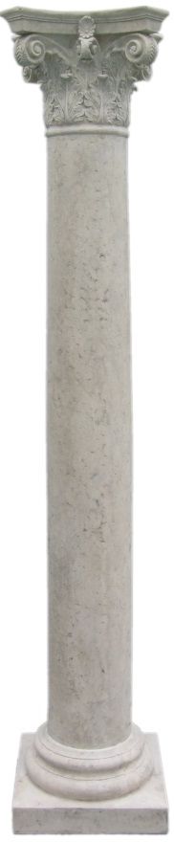
Goal: To better understand a various aspects of Ancient Roman culture.
Task: Create a poster advertising a part of Ancient Roman life that we have learned about so far. You must sell it to the viewer (your teacher) as persuasively as possible. Possible topics can include legion recruitment, gladiatorial games, bathhouses, restaurant/dinner parties, sale of a villa/apartment, running for political office, etc.

Requirements:
1. Title: Name of product/service/business

2. Short description of what you are selling and how it will benefit the buyer.
3. At least 1 relevant illustration
4. Location/contact information
Recommended:
1. Use Roman themes (font, illustrations, references) as appropriate
2. Use color!
3. Use the full sheet of paper provided. Avoid excessive white space!
4. Be Creative! Bonus points may be awarded for creative “extras!”

Grading Rubric
Presentation | Organization (0-5) Understandability (0-5)  Title (0-5) | 0 – 15 pts
Contents | Illustration (0-5)  Ad description (0-5)  Contact information (0-5) | 0 – 15 pts
Creativity | Originality (0-5)  Artistic interpretation (0-5) | 0 – 10 pts
Accuracy | Spelling/grammar (0-5)  Accuracy of Information (0-5) | 0 – 10 pts
 | Total: | 0 – 50 pts

Due Date: ________________ Please attach this sheet to the back of your poster

