Early Humans Foldable Assessment

Directions: Create a display of information about the 4 different types of early humans. See specific instructions below. Samples will be provided in class. Use your textbook and the internet as resources.

Front Cover: Label the front cover EARLY HUMANS. Be sure to include related artwork and keep it colorful and creative. See below.
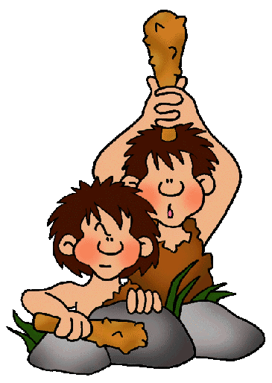
Early Humans
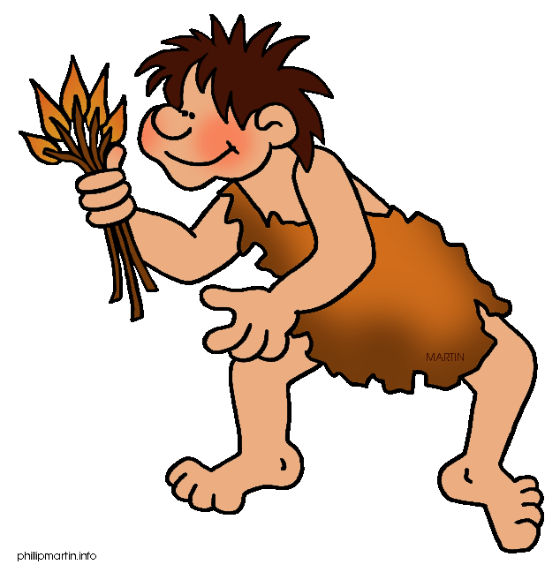

Inside Top: Title/label the 4 types of early humans across the top: Homo Habilis, Homo Erectus, Neanderthal, and Homo sapiens. Use your research to write 6 bullet points of important information.

Homo Habilis | Homo Erectus | Neanderthal | Homo sapiens

Inside Bottom: Illustrate each type of early human. Include a detailed caption. Illustrations should be colorful and reflect the early human you’re trying to represent. See below. Use the internet for more ideas.

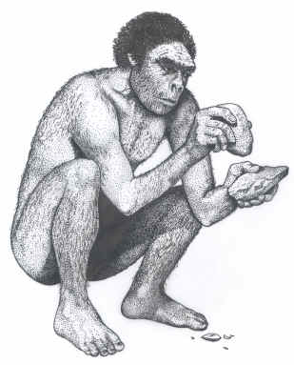 | 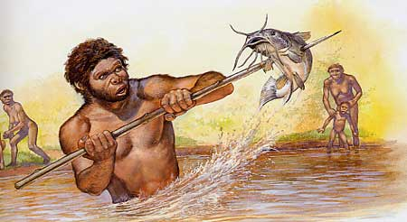 | 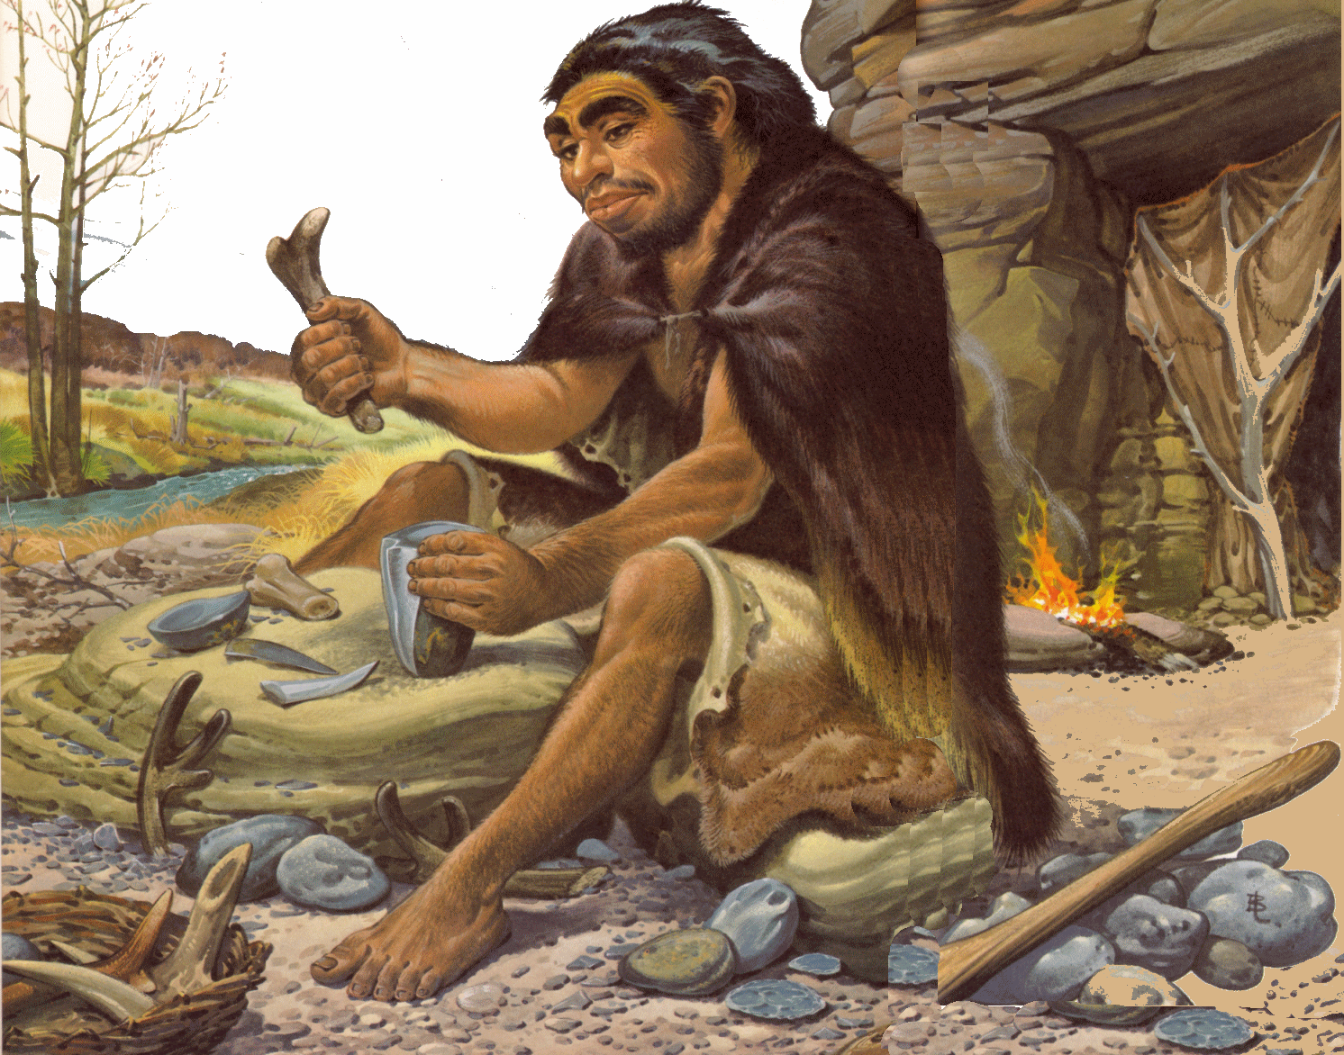 | 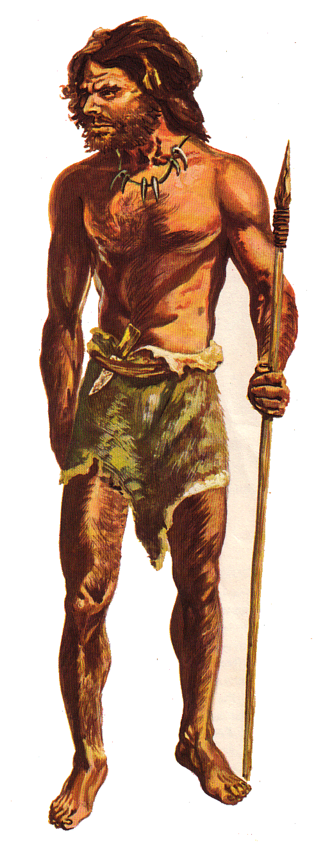
Write a caption | Write a caption | Write a caption | Write a caption

Early Humans Foldable Assessment Rubric

_________________________________
Name(s)

Requirement | Points Earned | Points Possible
Front Cover  Correctly Labeled  Colorful  Illustrations/Artwork |  | 20
Inside Top  Correctly Labeled  Accurate Information  Sufficient Information |  | 25
Inside Bottom  Detailed Captions  Thoughtful illustrations  Accuracy of illustrations & captions |  | 25
Neatness & Design  Neatness & Effort  Format & Layout  Colorful & Creative |  | 15
Language Conventions  Spelling  Grammar  Fluency  Capitalization  Punctuation |  | 15
Total |  | 100
Comments:

Student Sample

