GREEK ART
Balance and harmony are the main characteristics of Greek art. Painting is the less representative art as many works have not survived time. We can analyze ancient Greek painting in the pottery remains.
ARCHITECTURE
Ancient Greek buildings were covered with a flat roof or lintel. The most important buildings were the temples, the theatres. The hippodromes and the mausoleums.
TEMPLES
Temples were built to be the houses of the gods and only priests and priestesses could enter there. So, temples were built to perform outdoors ceremonies and rituals.
Temples could have rectangular or circular floor plans. To be admired from the distance, all temples are built over a stepped platform surrounded by columns.
Over the columns there is a horizontal structure called entablature divided into three parts: an architrave, a frieze, and a cornice. Temples were covered with a sloped roof which ends in two triangular pediments decorated with sculptures.
The main parts of the Greek temples were:
- The peristyle or gallery of columns surrounding the temple.
- The pronaos is the outer part or a temple forming a portico or hall.
- Cella is the central room of the temple, and it contains the statue of the god to whom is dedicated the temple.
- Opisthodomos is the room where the treasure is kept.

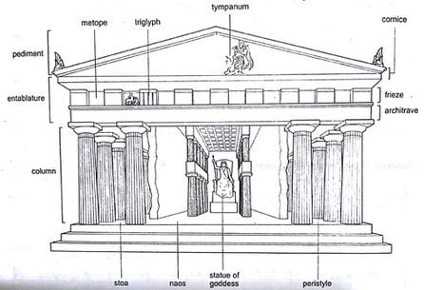

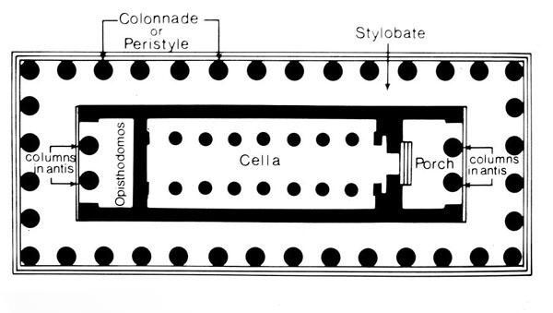

ARCHITECTURAL ORDERS OR STYLES
Temples can be classified depending on the design of the columns and entablatures:
- Doric style is the oldest and simplest style. The column has not base, the shaft is thick, and the capital looks simple in comparison with the other styles. The frieze is decorated with triglyphs and metopes.
- Ionian style is characterized by having a base, a narrower shaft and the capital decorated with spiral scrolls or volutes. The architrave is divided into three bands.
- Corinthian style is similar to the Ionic. Its capital contains acanthus leave decorations.

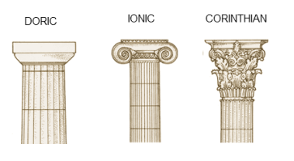
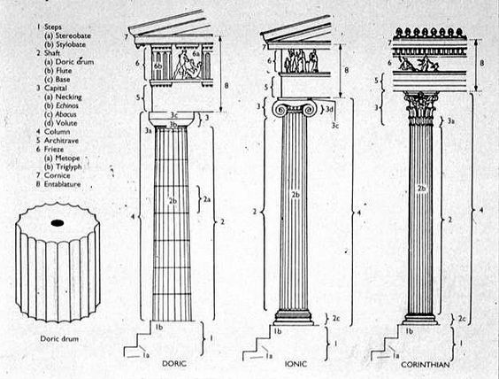
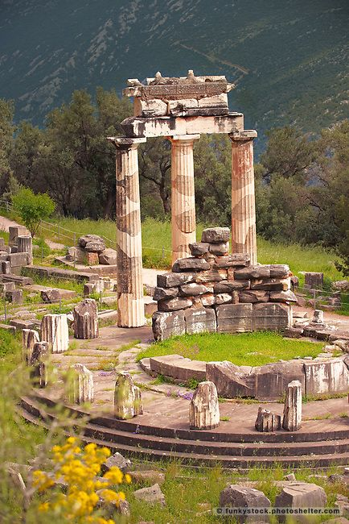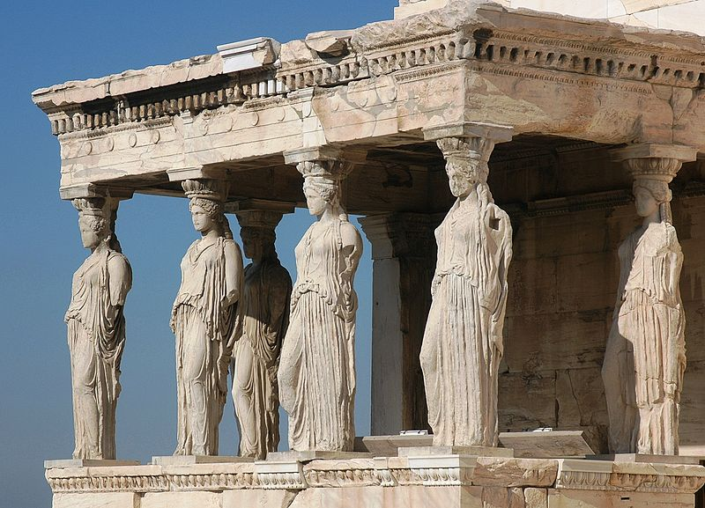

SCULPTURE
Greek sculptures had human shape and they were made of wood, limestone, marble, and bronze.
Greek sculpture was classified into three main periods:
- Archaic period: it was influenced by Egyptian sculpture however sculptures were more balanced. Faces were characterized by having big eyes, and a forced smile. Hair was very unnatural, and the statues lacked movement. Masculine nude statues were called Kouros while clothed women ones were known as Korai.
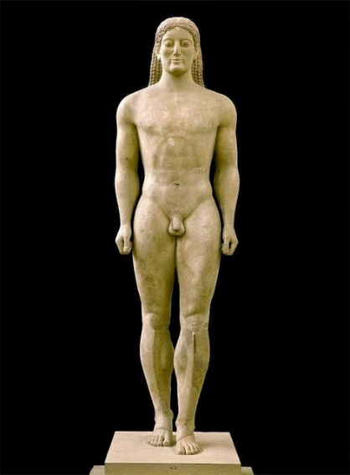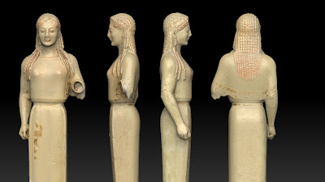v
- Classical period: Ideal beauty is represented with perfect proportions and harmony. The Greeks had different types of proportions or canons to represent human figures. Polykleitos invented the first canon which consisted of having a body with a length of seven times the size of the head.
Athletes and gods were represented naked, and the muscles and anatomic features were natural.
Other important sculptors of this period were Myron, Fidias from the 5th century BC and Lyssipos, Scopas and Praxiteles from the 4th century.

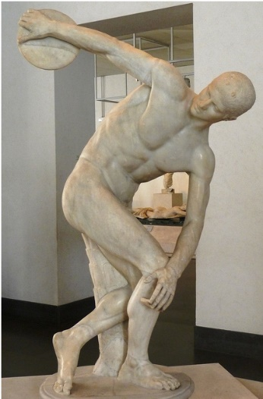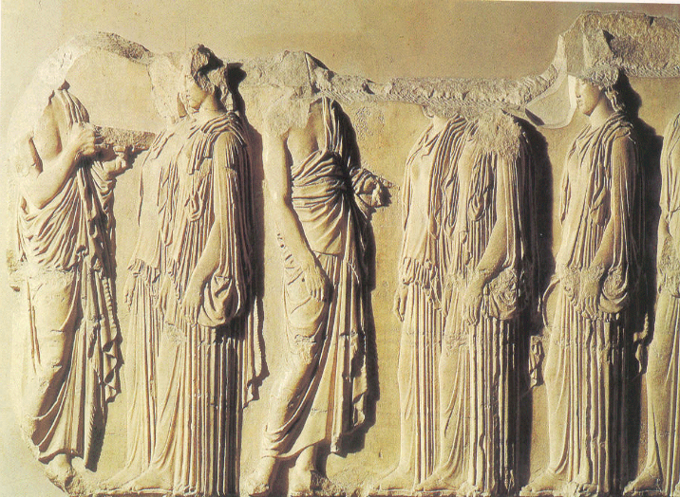
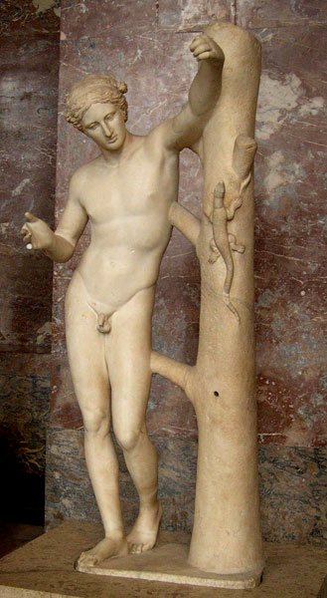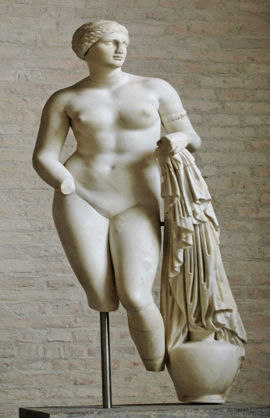
- Hellenistic period: the sculptures are much more expressive and represent movement. The ideal of beauty is not shown in these sculptures since they represent drama and realistic figures.
