Plate Tectonics, Continental Drift, and Pangaea (Worksheet) - Answer Key
- Use the map below to answer the next two questions. (Q.1 - Q.2)
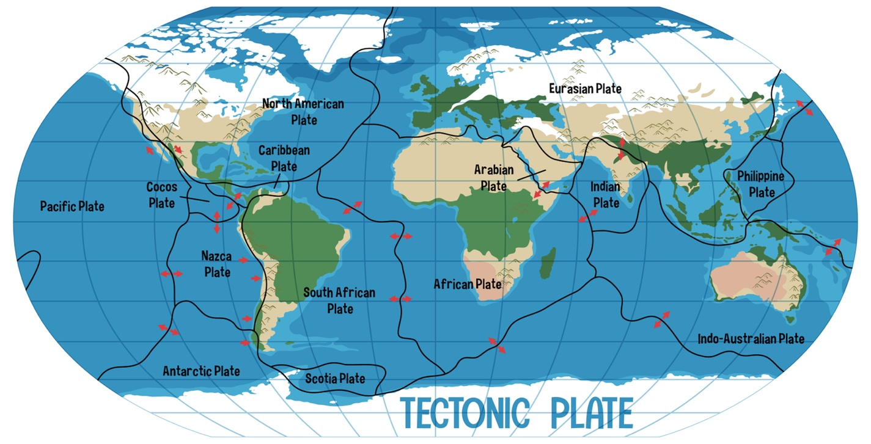
Q.1. Which of the following statements is false?
a) Tectonic plates are huge pieces that form the Earth’s crust.
b) Tectonic plates are different in shape and size.
c) There are no tectonic plates in the oceanic crust.
d) A plate boundary is a place where two tectonic plates meet.

Q.2. Which one of the following is not a tectonic plate?
a) Pacific Plate | b) Eurasian Plate
c) North American Plate | d) Canadian Plate

Q.3. Label the types of plate boundary. (Convergent, Divergent, or Transform)
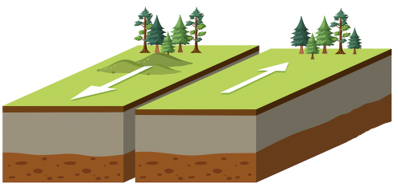  Motion: Lateral Sliding | Transform
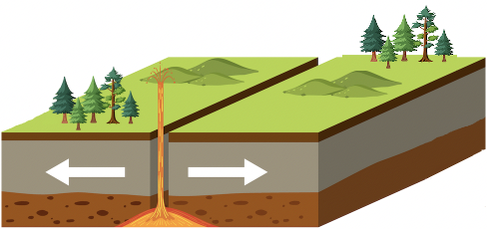  Motion: Spreading | Divergent
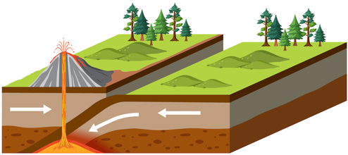  Motion: Subduction | Convergent

Q.4. What causes Earth's tectonic plates to move?
a) Convection currents in the mantle | b) Ocean tides
c) Earthquakes | d) Solar energy

Q.5. Which type of plate boundary is found in the San Andreas Fault system?
a) Convergent boundary | b) Divergent boundary | c) Transform boundary

Q.6. Which type of plate boundary is found in the Himalayan Mountains?
a) Convergent boundary | b) Divergent boundary | c) Transform boundary

Q.7. Which of the following terms is defined as the preserved remains or traces of ancient organisms?
a) Pangaea | b) Landforms
c) Laurasia | d) Fossils

Q.8. What is the name of the layer of the Earth that is composed of the crust and the upper part of the mantle?
a) Asthenosphere | b) Lithosphere
c) Inner Core | d) Mesosphere

Q.9. The following map shows some pieces of evidence that support the theory of continental drift.
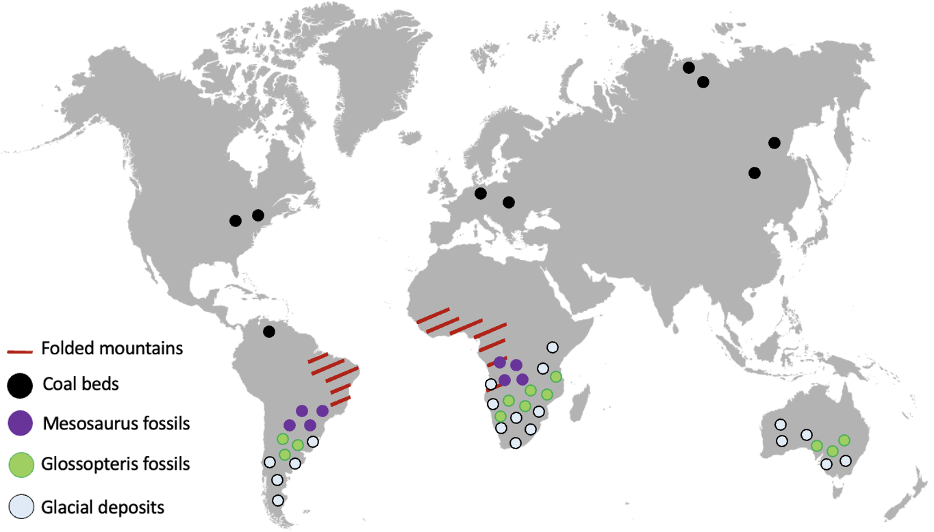
Which of the following is not evidence that supports the theory of continental drift?
a) The similarities of coastlines between continents
b) The distribution of fossils
c) The similarities of rock structure
d) The salinity of ocean water

Q.10. Which of the following scientists formed a hypothesis that continents are slowly moving around on Earth's surface?
a) Charles Darwin | b) Alfred Wegener
c) Harry Hess | d) Marie Curie

Q.11. What is the name of the hypothesis that continents are slowly moving around on Earth's surface?
a) Paleomagnetism | b) Supercontinent
c) Continental drift | d) Seafloor Spreading

Q.12. What is the name of Alfred Wegener's supercontinent?
a) Pangaea | b) Laurasia | c) Gondwana | d) Atlantis

Q.13. Which of the following is showing the ancient supercontinent of Pangaea?
a) | 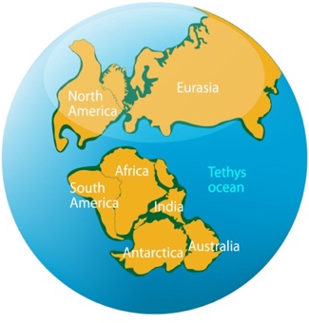 | b) | 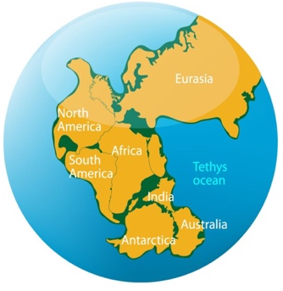 | c) | 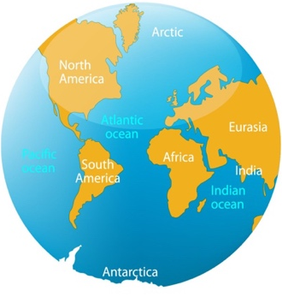

Q.14. Which of the following features are not caused by plate tectonics?
a) Bridges | b) Mountains | c) Earthquakes | d) Volcanoes

Q.15. What is the name of the layer of Earth that lies beneath the lithosphere?
a) Laurasia | b) Asthenosphere | c) Pangaea | d) Mesosphere

Q.16. Which of the following statements is false?
a) There are two types of Earth’s crust: oceanic crust and continental crust.
b) Oceanic crust is thinner and denser than continental crust.
c) The ocean floor is completely flat.
d) There are volcanoes, mountains, trenches, and canyons on the ocean floor.

Q.17. What is the name of the hypothesis that the formation of a new oceanic crust at mid-ocean ridges as the two plates move away from each other?
a) Paleomagnetism | b) Supercontinent
c) Continental drift | d) Seafloor Spreading

Q.18. Which of the following scientists proposed the theory of seafloor spreading?
a) Charles Darwin | b) Alfred Wegener
c) Harry Hess | d) Marie Curie

